# Experiment – 01

**1. Case Study for Success and Failure story of a software project.**

## 1.1 Success story of a software project

**1.1.1 Introduction**

* **Company : Nix United**
* **Project – Taxi App For Drivers** 
  + NIX United is a global software engineering company situated in Florida, USA .
  + It provides software engineering services like mobile development, web development, data science and big data, e-commerce development, and cutting edge, data engineering, business intelligence, artificial intelligence, cross-platform app development, enterprise mobility, integration and customization, management and consulting, quality assurance, and business analysis.
  + **Project type:** Android based - Mobile Application
  + **Business domain:** AutoMotive /AutoMobile
  + **The Project team consist of 15 members :** 
    - * Business Analyst
      * Project Manager
      * Designer
      * 8 - Android Developer
      * Java Developer
      * 3 - QA Engineer
  + **Technologies Used**: C++, Kotlin , Java , Crashlytics.

**1.1.1 Business Overview**

The client is a global taxi aggregator that supports over a million users in two separate mobile applications for taxi clients and drivers.

* + - * The client had the ambitious goal to outperform market leaders and grow their user base.
      * They sought a reliable vendor who would address the scope with proper tech and selected NIX as a proven expert.

**1.1.2 Challenges**

i. Improve the motivation program for taxi drivers to conquer a more expansive audience by creating a special feature ii. Enhance user experience and enrich app functionality iii. Speed up the process of feature releases

**1.1.3 Solution**

**i. To improve the motivation program for the taxi drivers**

* Developed an Android app from scratch that works as an auxiliary app for the taxi service and provides an opportunity to improve route quality, thus selecting the most optimal route.
* The app operates as a video recorder, recording GPS locations and sending content to the server
* Added new functionality for drivers to get priority orders if they have a good rating and use the video recorder app for enhancing routes **ii. To improve the user experience**
* Integrated a map that can simultaneously inform drivers about road situations
* Provided taxi drivers with the ability to locate the customer on the map, increasing the accuracy of taxi delivery and making it less time-consuming
* Added a feature that allows the user and the taxi driver to see the same route, which enhances the ride's security **iii. To speed up the release of the feature**
* Scalability for simultaneous development by a large number of developers and A/B testing on real users.
* Ability to turn on or off specific features for users depending on the city or taxi company and ensure stability if some functionality fails.

Dynamic delivery by installing and removing parts of an app while running to reduce the application’s space.

**1.1.4 Outcome**

* The client received an upgraded taxi app that provides unparalleled benefits to drivers.
* It gave them real-time information by showing various routes depending on the users’ locations and preferences.
* Moreover, the NIX team developed a new Android app from scratch for photo and video recording that captures road signs and traffic lights and sends them to the server, providing real-time data for the drivers.
* All enhancements helped the client to launch the updated product and market it in a timely manner, acquire a vast client base in the million-person cities, and become one of two country leaders.

## 1.2 Failure story of a software project

**1.2.1 Introduction**

**Case Study : Accenture Failed To Deliver a website to Hertz**

**About Hertz corporation :** The Hertz Corporation, a subsidiary of Hertz Global Holdings, Inc., is an American car rental company based in Estero, Florida, that operates approximately 12,000 corporate and franchisee locations, both domestically and internationally.

**About Accenture :** Accenture (USA) provides management consulting and professional IT services. The Company offers risk management, enterprise architecture application development, analysis, cloud computing, system integration, testing, and security services.

Accenture serves clients worldwide.

**1.2.2 Background Of The Project :**

* In early 2016, Hertz began an ambitious project to transform its digital identity.
* Lacking the internal expertise and resources to carry out the work itself, Hertz picked Accenture from a list of potential candidates to design, build, test, and deploy Hertz's new website and apps.

The revamped website was supposed to go live in December 2017, but the deadline was delayed to January 2018 then pushed back again to April 2018, which was also missed.

* By May 2018, Hertz lost patience and terminated Accenture's services. The car firm no longer had any confidence that Accenture was capable of completing the project.

**1.2.3 Reasons To Failure :**

* Accenture's failure to incorporate a website design that scaled to different devices. ➢ Accenture only created desktop and mobile versions but not the Tablet version.
* when Hertz asked about the tablet version, the firm demanded hundreds of thousands of dollars in additional fees to deliver the promised medium-sized layout.
* But Hertz has already paid $32 million for the development of the website.

**1.2.4 Technical Reasons To Failure :**

* Accenture ignored requests for a common core of libraries so Hertz could share information across all its websites and apps.
* Accenture deliberately disregarded the extensibility requirement and wrote the code so that it was specific to the Hertz brand in North America and could not be used for the Hertz global brand or for the Dollar and Thrifty brands.
* Accenture did not test the developed software, at least not thoroughly or in time.
* There were serious performance defects and security vulnerabilities in the code for the customer-facing ecommerce website.
* The Accenture developers were not able to integrate the back-end code (Java) with the front-end code (Angular) in an error-free, high-performance and secure way.

**1.2.5 Key Reasons To Failure:**

* Hertz rushed to complete the project within one and half year.
* Hertz did not have a development team of its own that could have implemented the project in-house.
* Miscommunication between Hertz and Accenture.
* Accenture’s problems with integration

# Experiment – 02

**2. Case Study to understand SDLC model.**

→ **Case study to understand Incremental Model**

## 2.1 Introduction

Incremental Model is a process of software development where requirements divided into multiple standalone modules of the software development cycle. In this model, each module goes through the requirements, design, implementation and testing phases. Every subsequent release of the module adds function to the previous release. The process continues until the complete system achieved.

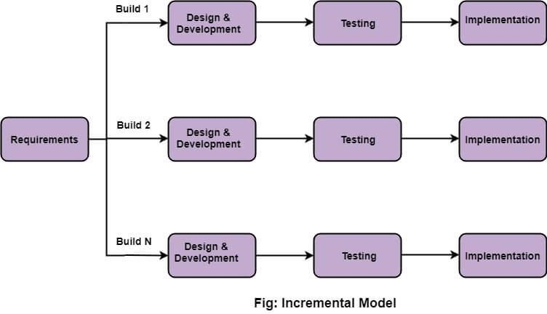

**2.1.1 Various phases of incremental model**

1. **Requirement analysis:** In the first phase of the incremental model, the product analysis expertise identifies the requirements. And the system functional requirements are understood by the requirement analysis team. To develop the software under the incremental model, this phase performs a crucial role.
2. **Design & Development:** In this phase of the Incremental model of SDLC, the design of the system functionality and the development method are finished with success. When software develops new practicality, the incremental model uses style and development phase.
3. **Testing:** In the incremental model, the testing phase checks the performance of each existing function as well as additional functionality. In the testing phase, the various methods are used to test the behavior of each task.
4. **Implementation:** Implementation phase enables the coding phase of the development system. It involves the final coding that design in the designing and development phase and tests the functionality in the testing phase. After completion of this phase, the number of the product working is enhanced and upgraded up to the final system product

**2.1.2 When to use the Incremental Model**

* + When the requirements are superior.
  + A project has a lengthy development schedule.
  + When Software team are not very well skilled or trained.
  + When the customer demands a quick release of the product.
  + You can develop prioritized requirements first.

**2.1.3 Advantage of Incremental Model**

* + Errors are easy to be recognized.
  + Easier to test and debug ➢ More flexible.
  + Simple to manage risk because it handled during its iteration.
  + The Client gets important functionality early.

**2.1.4 Disadvantage of Incremental Model**

* + Need for good planning ➢ Total Cost is high.
  + Well defined module interfaces are needed.

## 2.2 Case Study

**Scenario: To develop a web-based** [**social network**](https://t4tutorials.com/social-networks-mcqs-solved-questions-answers/) **with the following functionalities;**

* The user should [signup](https://t4tutorials.com/sign-in-login-logout-signup-in-php-and-mysql) for the system.
* The user should log into the system and can send or accept the friend request.

**Solution**: Convert this system into separate components;

1. Sign up and log in
2. Send Friend request
3. Accept friend request

**Component 1:** Sign up and log in

Now, when we start our activities, then we can start with component 1(signup and login). This component undergoes the phases of requirements gathering and analysis, design,

implementation, deployment, and maintenance. When this component is ready, we deliver this one component to the customer.

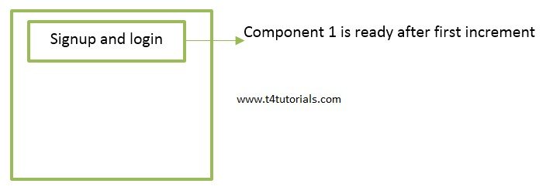

**Component 2:** Send Friend request

After that, we add or increment another component 2 that sends the friend request. This component undergoes the phases of requirements gathering and analysis, design, implementation, deployment, and maintenance. When this component is ready, we deliver this one component to the customer.

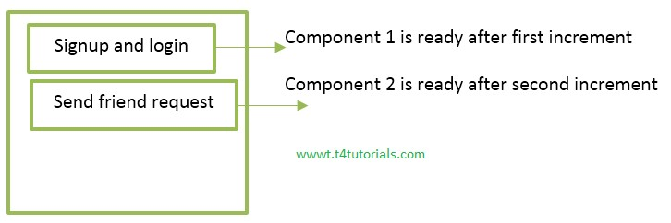

**Component 3:** Accept Friend request

After that, we add or increment another component 3 that accepts a friend request. This component undergoes the phases of requirements gathering and analysis, design, implementation, deployment, and maintenance. When this component is ready, we deliver this one component to the customer

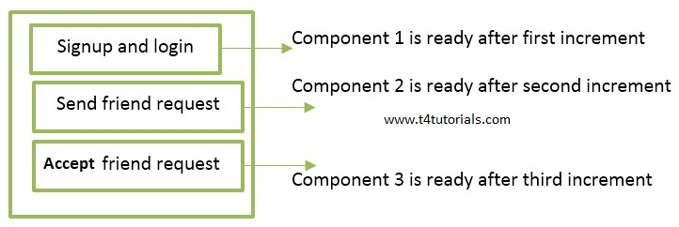

**Result:** In this case study we observe that one system is produced and delivered to the customer in increments.

# Experiment – 03

**3. Case Study to understand SDLC model.**

→ **Case study to understand Agile Model**

## 3.1 Introduction

Agile development model is also a type of [Incremental model.](http://tryqa.com/what-is-incremental-model-advantages-disadvantages-and-when-to-use-it/) Software is developed in incremental, rapid cycles. This results in small incremental releases with each release building on previous functionality. Each release is thoroughly [tested](http://tryqa.com/why-is-testing-necessary/) to ensure [software quality](http://tryqa.com/what-is-software-quality/) is maintained. It is used for time critical applications. Extreme Programming (XP) is currently one of the most well known agile [development life cycle model.](http://tryqa.com/what-are-the-software-development-models/)

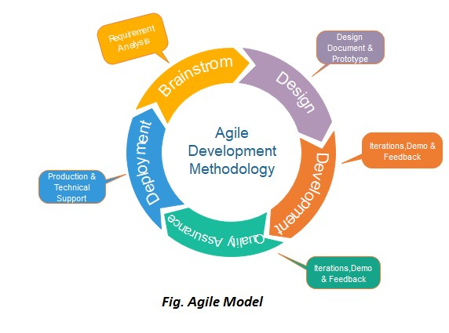

**3.1.1 Phases of Agile Model:**

1. Requirements gathering
2. Design the requirements
3. Construction/ iteration
4. Testing/ Quality assurance
5. Deployment
6. Feedback
7. **Requirements gathering:** In this phase, you must define the requirements. You should explain business opportunities and plan the time and effort needed to build the project. Based on this information, you can evaluate technical and economic feasibility.
8. **Design the requirements:** When you have identified the project, work with stakeholders to define requirements. You can use the user flow diagram or the high-level UML diagram to show the work of new features and show how it will apply to your existing system.
9. **Construction/ iteration:** When the team defines the requirements, the work begins. Designers and developers start working on their project, which aims to deploy a working product. The product will undergo various stages of improvement, so it includes simple, minimal functionality.
10. **Testing:** In this phase, the Quality Assurance team examines the product's performance and looks for the bug.
11. **Deployment:** In this phase, the team issues a product for the user's work environment.
12. **Feedback:** After releasing the product, the last step is feedback. In this, the team receives feedback about the product and works through the feedback.

**3.1.2 When to use the Agile Model** o When frequent changes are required.

* + When a highly qualified and experienced team is available.
  + When a customer is ready to have a meeting with a software team all the time.
  + When project size is small.

**3.1.3 Advantage of Agile Method**

* 1. Frequent Delivery
  2. Face-to-Face Communication with clients.
  3. Efficient design and fulfils the business requirement.
  4. Anytime changes are acceptable.
  5. It reduces total development time.

**3.1.4 Disadvantages of Agile Model**

* 1. Due to the shortage of formal documents, it creates confusion and crucial decisions taken throughout various phases can be misinterpreted at any time by different team members.
  2. Due to the lack of proper documentation, once the project completes and the developers allotted to another project, maintenance of the finished project can become a difficulty.

## 3.2 Case Study

**Scenario : To build an ‘Add Search Filter’ feature in an Online Food Ordering System.**

➢ Any feature goes through the following phases:

1. Ideation
2. Design
3. Implementation and Testing
4. Deployment
5. **Ideation:**
   * By adding more filters, a customer can only view restaurants that are relevant to them. Filters could be of the following.
   * Since all the features cannot be released in one sprint, 1. Filter by location 2. Filter by restaurant cuisine in the initial phase.
6. **Design:**
   * Filter by location will contain a checkbox and filter by restaurant cuisine could be a drop-down of multi-selectable options like North Indian, Italian, etc.
   * After selecting the cuisine the customer is redirected to a page that shows relevant restaurants.
   * These options can be below the search on the page. Upon selection, the filter should slightly move upward making room for the display of restaurants.
   * Design team build screens for filter by location and filter by cuisine.
7. **Implementation and testing:** Developers build functionality and testers conduct testing.
8. **Deployment:** The feature is deployedand user experience is analyzed by tracking some events and taking feedback.

# Experiment – 04

**4. Document a Software Requirement Specification for a Web – based application.**

→ **SRS – College Management System**

## 4.1 Introduction

* This is a Website/Web-Based application.
* This document describes the software requirements specification (SRS) for the Collage Management System that provides the access and management of information about different modules in a collage-like Students, Guardians, Teachers/Faculty, Finance, Examination.
* The project is based on a database, which stores and maintains the information of different modules within the system.
* This document describes the details of the product, its parameter, and its goals.
* This SRS document describes the targeted audience, user interface of product and Software/Hardware requirements of the product.

## 4.2 Scope Of The Project

* As Colleges are growing day by day more and more, and also increasing the complexity of storing information of students and related to the college system, they face many related issues attendance and fee of students, salary details of employees, etc.
* Manual College systems were paper-based and difficult to maintain, expensive, more manpower required and unable to handle large records, the previous system was not efficient, not effective and there were issues of redundancy and consistency.
* The main goal of this application is to give maximum services in a single software product that is used by teacher and system administrator.
* **Advantages** :
  + It avoid entries in hard copies
  + saves the human power and time cost to perform the same task
  + The data in the database can be saved for a long time and can be used for different purposes in the future.
  + In management systems, there is a minor chance of losing the data.

## 4.3 Purpose

* The main objective of the product is to maintain information about students, employees and other activities like :
  + attendance,
  + student marks,
  + fee payment
  + salary payment, etc.
* The purpose of this document is to retrieve and analyze the ideas that define the product and requirements that the user needs.
* The information is stored for decision making in the future for a business process within an organization.
* The system is a Desktop web Application and GUI for this system is developed in C#.

The Database for this management system is created in SQL.

## 4.4 Proposed System

* In this project, the system is proposed by understanding the issues in the existing system. In this management system the problems are solved that were in the previous system by shifting on a computerized system of the modern age.
* The SQL database is used to store the data at the backend of the system.
* The graphical interface GUI of the product is developed in c#.
* Whenever the system get the data from the user and store it into the database, Reports of stored data are generated through Crystal reports.
* The system that is proposed provides consistent and redundancy free data in storage and should be more efficient.
* This system provides the security of data by authentication and authorization of users.

## Product Perspective

* **User Interface :** The application that will be developing will have a user – friendly and menu based interface.
* **Following screens will be provided :**
  + A login screen entering the username and passwords, so that the authorized user can have an access without any problems.
  + There will be a screen for displaying major tasks happening while add details, delete and view the details of student or the employee.

**Assumptions :**

* The product require a computer with proper LAN connectivity.
* The system must be able to respond to the database Software within reasonable time

## 4.6 User Types and Authorities

* This management system is controlled by the System administrators and teachers.
* In this system, admin is the main user who has full access to the management system.
* Admin can view and modify the records like :
  + student’s profile ,attendance, fee, results,
  + details of teachers
  + other employees in college,
  + their personal information and their attendance for their salaries.
* Teachers have access to view and modify the student’s information like their attendance, marks of exams to generate the progress report of students. When the teacher update the student’s information then admin can view this information.
* In this product, different reports can be generated, pay slips of employee salary, fee report of fee payment if students, student details, attendance report, etc.

## 4.7 Operating Environment

* The software will be installed on different computer systems within a college and software will be connected to a centralized database through LAN within a college.
* This application is developed only for windows operating system that can be run on Windows XP and above.
* The centralized database is used to store the information.

The user only within the college (members of college staff) can use this management system.

* The CMS is expected to be deployed in a real environment to manage the DBMS inside the college.
* Users outside from the college cannot access the management system. The database is used in different departments within a branch of the college.
* Admin can view all of the information that is stored in the database through application.

**4.8 Methodology :**

* The Agile model is a model of SDLC which is a combination of two process models incremental and iterative.
* CMS is developed on the basis of incremental process model of the Agile model which allows the user to divide the large project into different parts/ modules.
* In the incremental model the versions/parts of the system are delivered to the user after a regular interval of time, to get feedback from the user that is it cleared or he/she want any more changes in the given module.
* If the user wants any type of change in the product then it is possible through the incremental model.

## 4.9 The Main Modules which are focused on this project

* Student management
* Employee management
* User registration
* Reports of all modules (Crystal Reports)

## 4.10 Functional Requirements of the College Management System

The [functional requirements](https://t4tutorials.com/which-of-the-following-is-a-functional-requirement/) of this system are:

**4.10.1 Student management**

Register new students.

Record the attendance of students.

* Record the internal marks of students.
* Record the feed details of students.

**4.10.2 Employee management** ➢ Register a new teacher/employee.

* Register a new user for the system.
* Record the salary details of employees.

**4.10.3 User Registration**

* Identification Details(Such as User Id , Name, Mail-Id)
* Authentication Information(Password , Pin)
* Access Privileges

**4.11 Use Case Description:**

**Name: User registration**

**Description:** admin can create new users for the system which are employees of the college. Admin creates their profile for the user and provides the user name and password to login to the system.

**Precondition:** The user must be an employee of the college. One user can have only one user name about his profile.

**Flow :**

* Check availability for a user if the user is new then it is able to create a new users for the system.
* Enter the details of the user needed to create a new user.
* Save the record if new entry.
* When data is entered then save the information and register the user.
* Admin can edit the information (user name/ password etc.).
* “update” record if any change is made.

Users can “Delete” the existing records.

**Postcondition:** User registered.

## 4.12 Product Features of the College Management System

The CMS contains the following key features:

**4.12.1 Admin:**

* Admission /Registration: Add new students to register them with their personal information/details.
* Staff: Admin will add new staff/Teachers/Employees by inserting their personal information and register them.
* Admin can add a new user for the CMS by assigning them a login/username and password
* Finance: Admin can view and manage the financial transaction for the college
* Scholarship: Admin can assign scholarships to the students.

**4.12.2 Employee:**

* Personal information: personal details of staff name, address, contact, etc.) will be stored.
* Attendance: store and represent the attendance details of staff.
* Salary: provides details about the salary of staff

Student information: Teachers can view the details of their students and provide access to the teacher to update and manage the student’s exam marks

**4.12.3 Student :**

* Personal information; This will provide all the details about a student like his/her name, address, Guardian, etc.
* Attendance: This feature provides the attendance details of the student.
* Marks: This will provide the marks of student internal marks in exams.

Fee: This will use to keep a record of student fees and in the future by using this feature Admin can view the fee record of any student within the college.

**4.12.4 Department :**

* This will provide the details about departments within a college with their name and every department have its Department name.

**4.12.5 Scholarship :**

* Types: scholarships may have different types like Need-based scholarship, Meritbased scholarship and scholarship provided by any external.
* Scholarship information: Every scholarship have its own name and also have a unique ID and description about it.
* Details: Details of the scholarship will be provided.

## 4.13 Non- Functional Requirements of the College Management System

**4.13.1. Performance requirement**

* The proposed system will be used as the main performing system for providing help to the college in managing the whole database of the college management system.
* Therefore it is expected that database would perform functionally with all the requirement that are specified.
* The system has a **consistent interface** so that the system is easy to use and in the interface of the system buttons and forms are used to enter data related to a specific module.
* The system should be easy to handle.
* The response time should be fast.

**4.13.2. Security Requirement**

* In this system, the authentication of the user is an important factor.
* In this system, user authentication will be done by login by user name and password and classified by user type.
* Depending upon the category of the user the access rights are decided. It means if the user is an administrator then he can be able to modify the data, append etc. All other user have the rights to retrieve the information about database.

## 4.14 Hardware And Software Requirements

**4.14.1 Hardware Requirements :**

* System : Pentium IV or above.
* RAM : 1GB or above.
* Hard Disk : 10GB or above.
* Operating System : Windows& or above.

**4.14.2 Software Requirements :**

* C# , Visual studio code , SQL Server , .Net Framework 3.5

# Experiment – 05

**5. Create User Stories for the Software Requirement Specification Document.**

→ **Registration and Login Module**

**EPIC – Implementation Of sign up and login functionality**

## 5.1 User story - 1

“As a System admin, I want to able to create new user with the accurate login credentials”.

**Acceptance Criteria** :

There will be input fields like : 1.Name,2.Email-ID,3.User type,4.new password and

5.new user-id.

**Specifications** :

* The name and email id fields contains the employee name and email-id respectively.
* User type field contain whether it is admin or employee
* The password field contains atleast 8 characters,1 number,1 uppercase letter and 1 special character
* The user-id field contain the employee id provided by the college.
* When I click on the sign up button with the credentials, A new user should be registered and to be able to login.

## 5.2 User story - 02

“As an Admin I want to register new employees in college and saves their information in a database so that I can manage the employee data”.

**Acceptance Criteria :**

* **Given(Precondition):** the Desired person must fulfill the eligibility criteria that are defined by the college to get employment in college.
* **Flow :**
* Check whether the person is eligible to get employment in college.
* Provide a form to the person to get the information about the employee.
* Check whether the information is filled correctly in the form.
* Enter the data into CMS through an interface.
* Save the information about that person.
* Registered as an employee.
* Edit the existing information and “update” if any change is made.
* User can “Delete” the existing records.
* **Then:** The employee registered.
* **Alternative Flow:** if the information given by the employee is incomplete or employee didn’t fulfill the criteria of college, the employee cannot be registered

## 5.3 User story - 3

* “As a registered user, I want to log in with my user id and password so that the system can authenticate and remember me and my data”.

**Acceptance criteria**:

* Given that I am a registered user and logged out, if I go to the log in page and enter my username and password and click on Log in, then the data associated to my userI*d* should be accessible.
* Given that I am a registered user and logged out, if I go to the log in page and enter my user-Id but an incorrect password and click on Log in, then log in fails with an error message that specifies that the username or password was wrong.

**5.4 User story - 4**

* “As a registered user, I want to be able to occasionally change my password so that I can keep it secure and I don’t permanently lose access to my data”.

**Acceptance Criteria** :

* Given that I am a registered user and forgot password there should be a “forgot password ” menu so that I can generate new password.
* The forgot password function would be based on the authentication of User-id by sending OTP to the linked mobile number.

# Experiment – 06

**6. Draw the Use Case diagram for the user stories using StarUML tool.**

→ **SRS – College Management System**

## 6.1 Use Case Diagram For Student Module

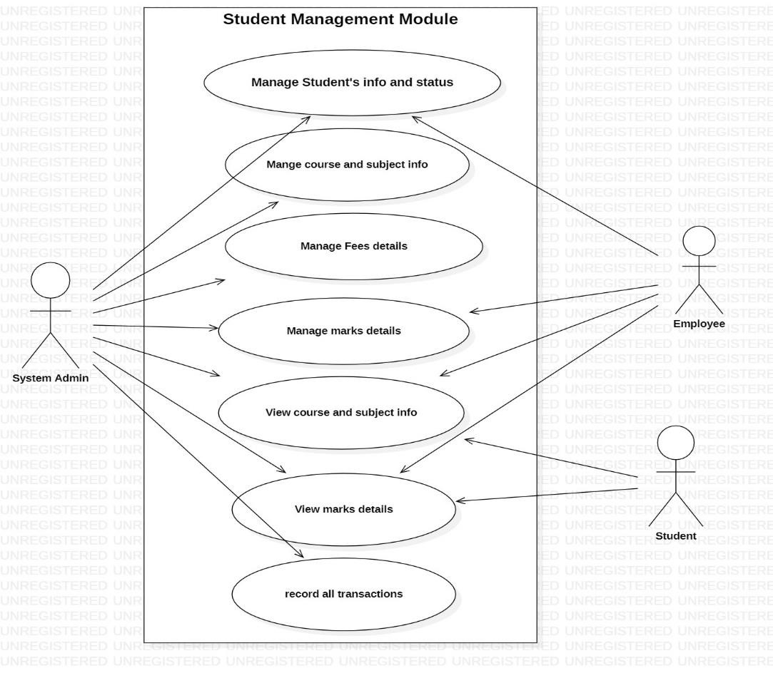

## 6.2 Use Case Diagram For Registration And Login Module

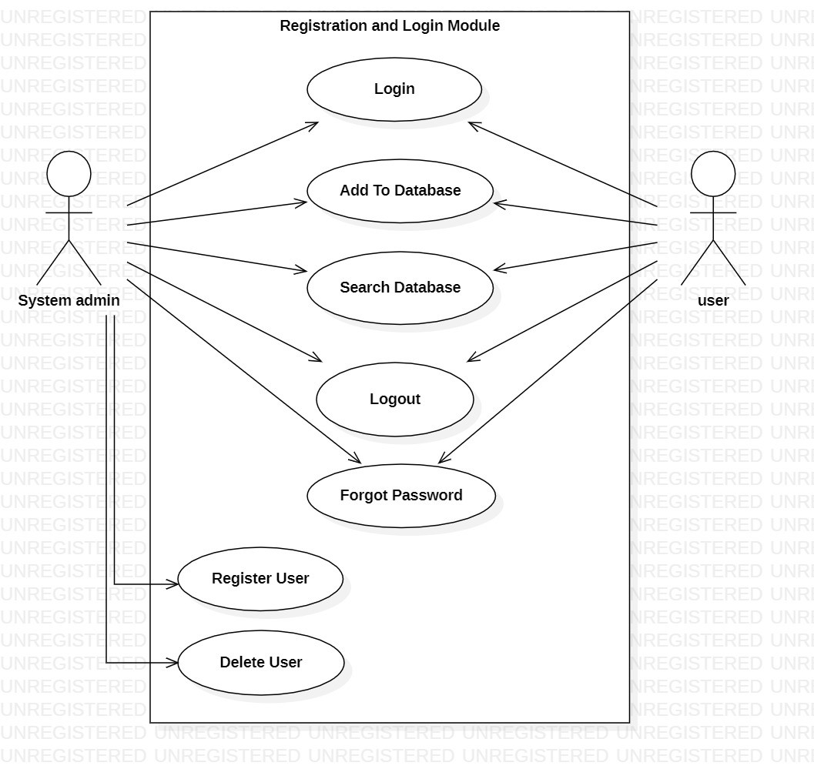

**5.3 Steps to create registration Module Use case diagram in StarUML.**

1. Select first an element where a new Use Case Diagram to be contained as a child.
2. Select Model → Add Diagram → Use Case Diagram in Menu Bar or select Add Diagram → Use Case Diagram by right clicking on the workspace.

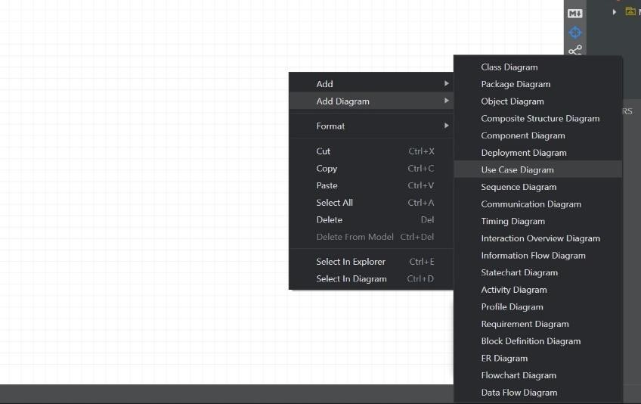

1. Select Use Case Subject in Toolbox.
2. Drag on the diagram as the size of Use Case Subject.
3. Select Actor in Toolbox.
4. Drag on the diagram as the size of Actor.
5. Select Use Case in Toolbox.
6. Drag on the diagram as the size of Use Case.
7. Rename the Use case subject , actor , use case.
8. Connect the actors to the use case through different association connectors in the toolbox.

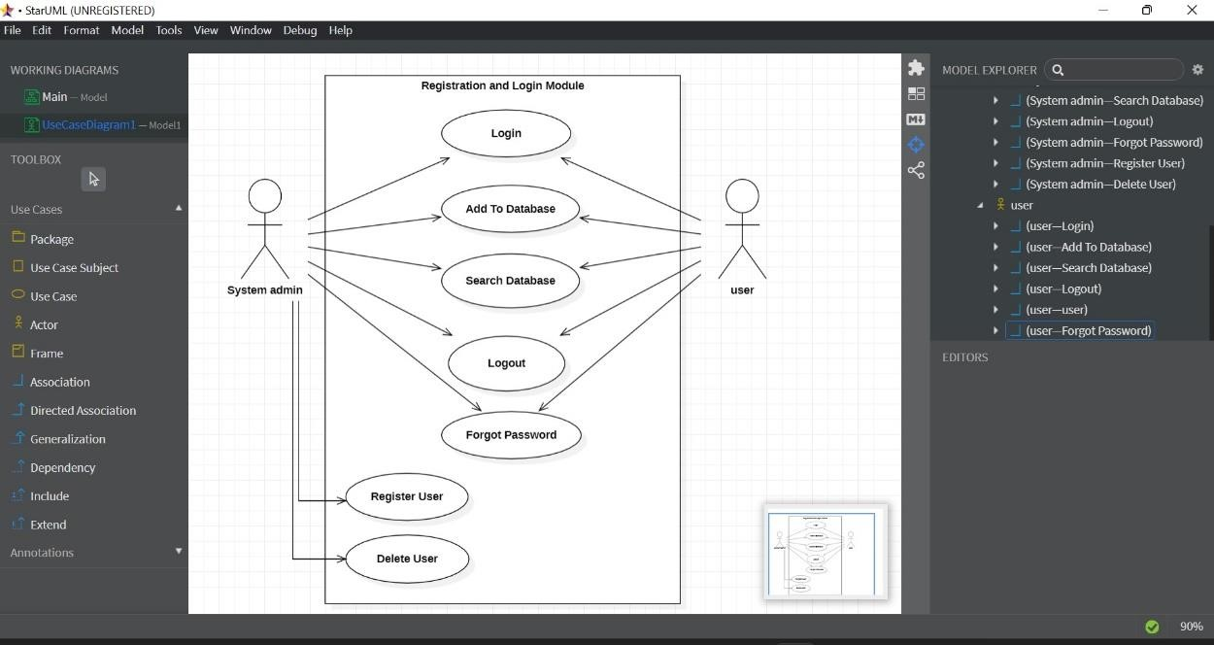

1. Upon completion of the diagram export it as your specific choice.

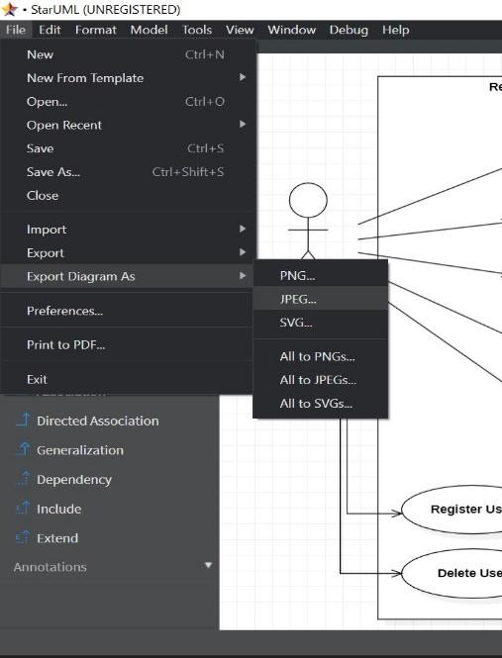

# Experiment – 07

**7. Identification of risk for a software project.**

→ **Project – College Management System**

## 7.1 Project delays and overrun

* For large-scale IT projects to run over their budgets and timeframes.
* This, depending on the project, can have a seriously detrimental effect on its overall value.
* Intranet software projects, because there’s so many different facets to them, run a particularly high risk of cost and schedule overrun.
* Intranet projects require a huge investment, not only in terms of finance, but also various other resources, such as staffing, time, and changing business priorities.

**Risk Mitigation :**

* The simplest way to minimize this kind of risk is by drafting a clear and comprehensive plan.
* Take the time to get a clear idea of the scope of your project, then leave yourself some wiggling room in terms of the required timeframe and staff.
* It’s also important to set out an effective framework for the sign-off and decisionmaking processes.

## 7.2 Lack of stakeholder involvement

* A huge proportion of [corporate intranet](https://www.claromentis.com/intranet-software-platform/) projects crash and burn, simply because the higher-ups at the organisation don’t pitch in enough.
* Even if you’ve been given full responsibility for the intranet project in question, getting major stakeholders involved will make it easier to initiate the necessary changes in your company culture, reduce the chance of low adoption, and secure those figures who will be the most effective at motivating and engaging the end users.

**Risk Mitigation :**

* Start off by mapping out the key stakeholders, and gauging their level of interest.
* Identify their major objectives, and how your intranet project will contribute to these.
* This should help you secure the necessary support for your project, and all the benefits that will come with it.
* Be sure to keep an open line of communication, especially when things go wrong.
* Transparency and frequent updates are integral to the success of these projects.

## 7.3 Resource and staffing risks

* The average intranet software project requires work from many different departments and individuals.
* This is true both for the implementation process, and after the system goes live.
* The human resources needed for the project can either come from within the company, or externally.
* If project lean on the workforce within the organization, it will run the risk of staff having to stay on top of their intranet responsibilities, alongside their standard, day-today tasks.
* These instances of conflicting priorities can really slam the brakes on an otherwise promising project.

**Risk Mitigation :**

* In the planning stage, make sure that all roles and responsibilities for the team are agreed upon.
* Everyone involved should know precisely what’s expected of them, both over the course of the project and afterwards.
* If, for whatever reason, certain roles and responsibilities change, then the handover needs to be planned carefully, then documented and agreed upon by all the relevant stakeholders.
* While requirement changes can also mark a significant risk for intranet projects.
* If any key requirements change while the project is still ongoing, it can easily result in long periods of downtime and higher overall cost.

## 7.4 Sub-par content management

Companies requiring an intranet system have huge knowledge assets.

* An intranet needs to be designed in a logical and user-friendly way, ensuring the entire workforce can use it confidently, and find whatever it is they’re looking for.
* Content management is absolutely essential to the short and long-term success of an intranet.
* When content is managed poorly, the system will become nothing more than a chaotic dumping-ground for information in different forms.
* This will lead to much of the content becoming outdated and useless, which in turn will lead to lots of wasted time and effort.

**Risk Mitigation :**

* When planning out an intranet project, It is necessary to make information governance and architecture a major part of the process.
* Profiling staff by user types, and having a thorough understanding of frequent tasks and user journeys, can be a huge help when you’re creating information architecture from scratch, as it will give you clear requirements your content management will have to meet.
* It’s a good idea to form a partnership with an intranet specialist, who will be able to provide the support and services needed to guide you through the process.

# Experiment – 08

**8. Create Jira account and learn interface.**

**Jira is software application used for issue tracking and as a project management tool, it is developed by a Australian sf company Atlassian, o is widely used by agile development to track bugs, stories, epics and other tasks**

## 8.1 Steps to create Jira cloud account

**Step 1:** Go to your preferred browser and search Jira login. Open the id.Atlassian.com link.

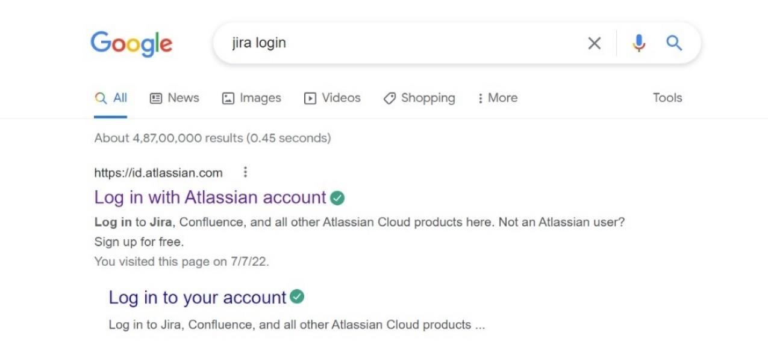

**Step 2 :** On the login page, click on sign up for an account to create a new account.

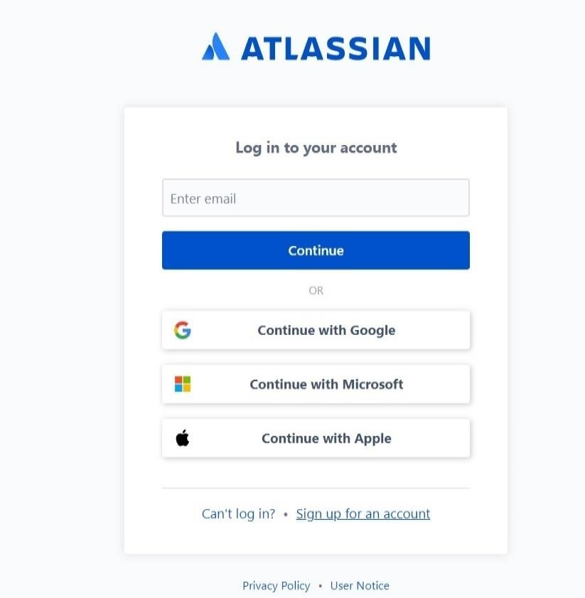

**Step 3 :** Select your Gmail account or type manually and click on create your account.

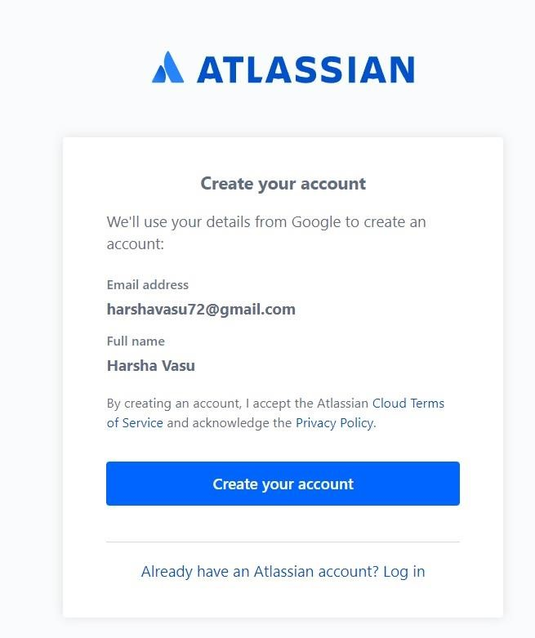

**Step 4 :** An Atlassian account will be created. On the home page → Our Products → Select Jira software.

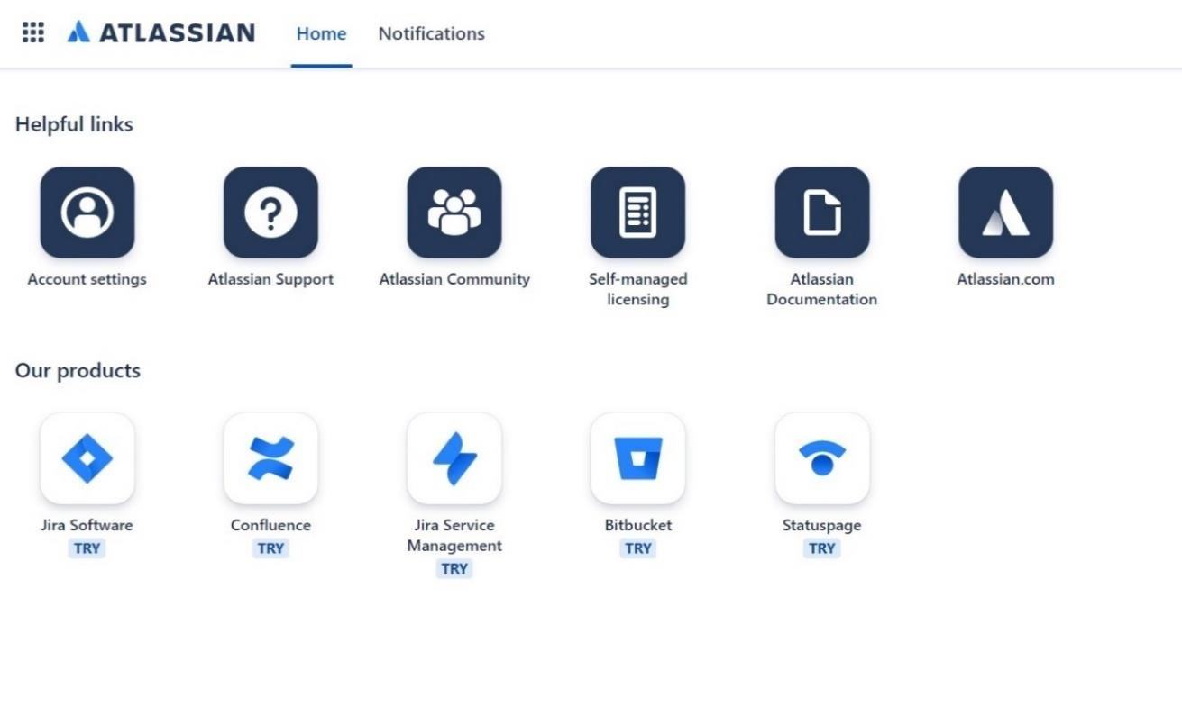

**Step 5 :** A cloud account page of Jira will appear. Enter your Gmail address and site name of your choice and click on Agree.

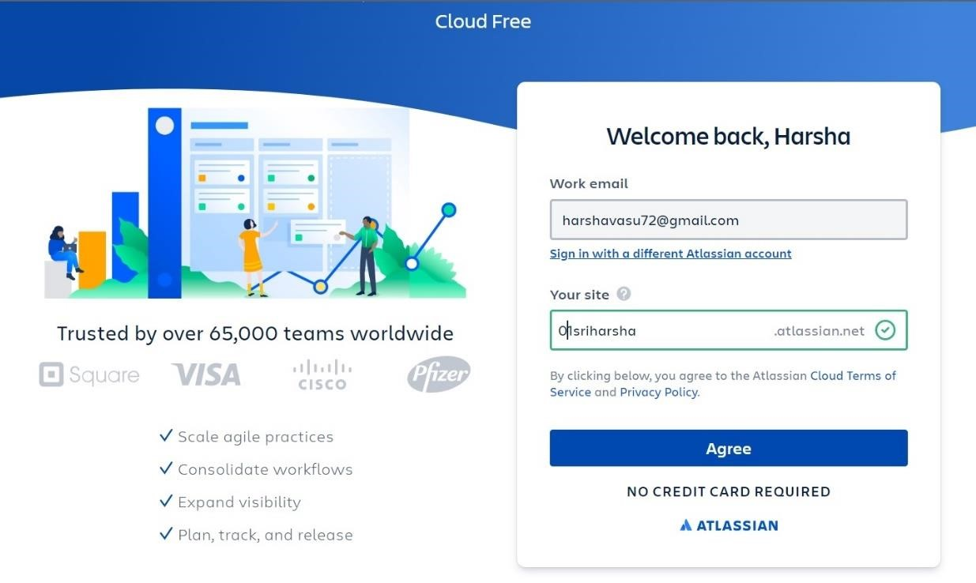

**Step 6 :** Next Jira will ask some questions answer it or skip the questions.

**Step 7 :** The Jira account is successfully created and redirected to the Jira dashboard.

## 8.2 Steps to create a project and user stories in Jira

**Step 1 :** On the home page of Jira, Click on Project menu and select create project.

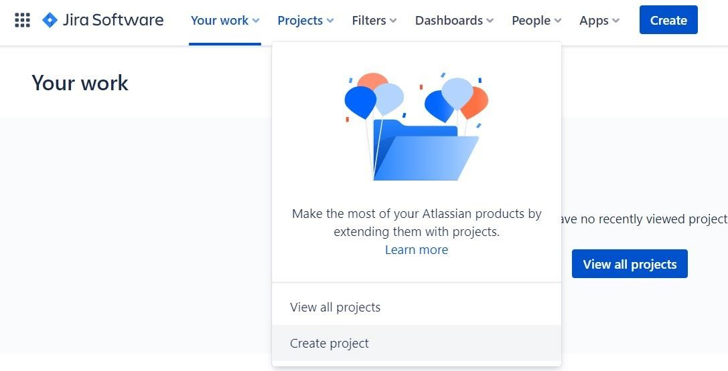

**Step 2 :** In next page, Select the template for the project i.e. Scrum.

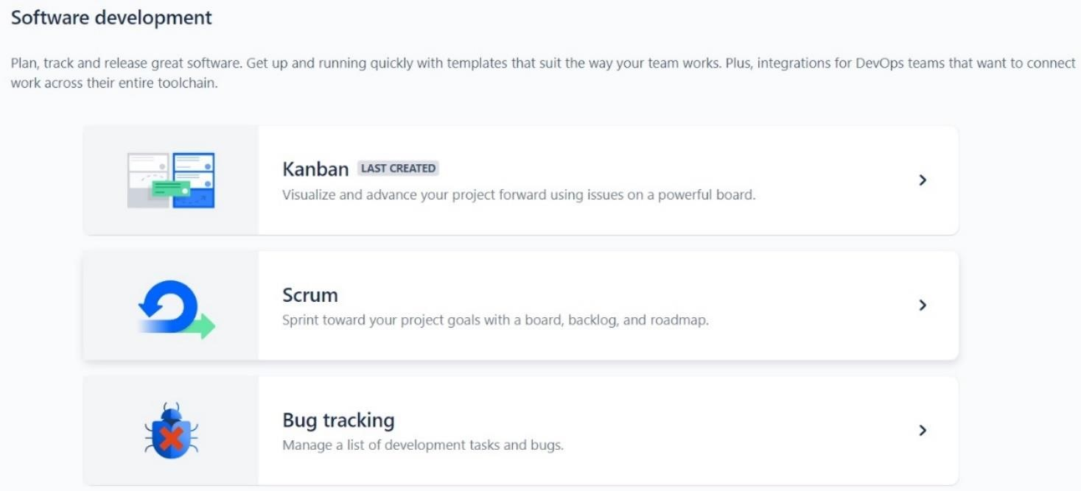

**Step 3 :** Select the type of the project i.e. Select team – managed project.

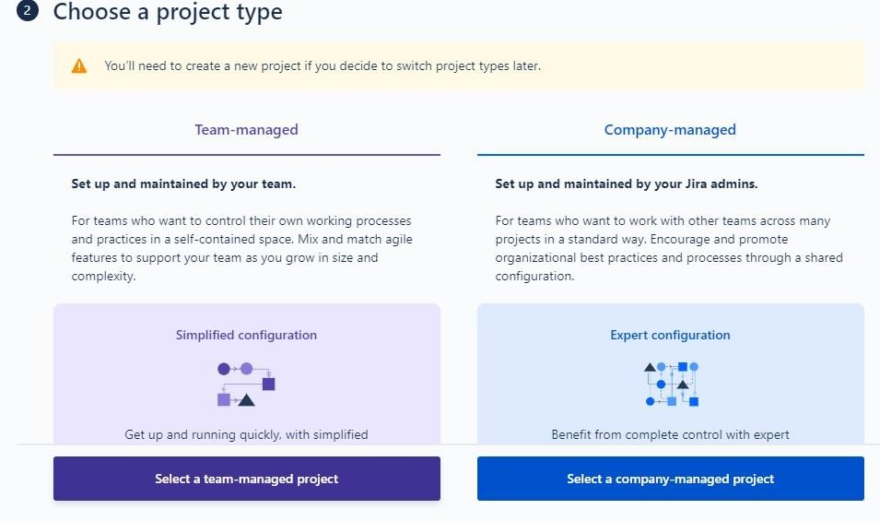

**Step 4 :** In the next page, Enter project name and click on create project.

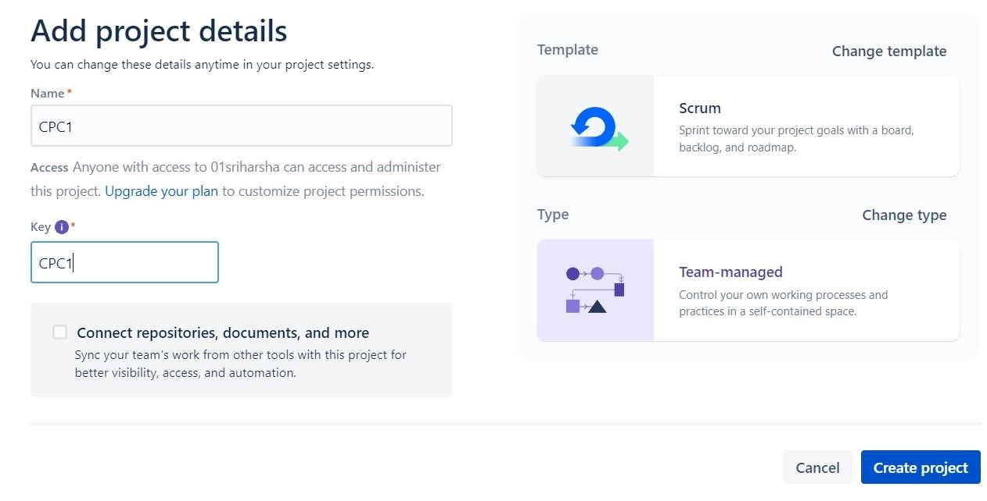

**Step 5 :** Invite the teammates through their Gmail address.

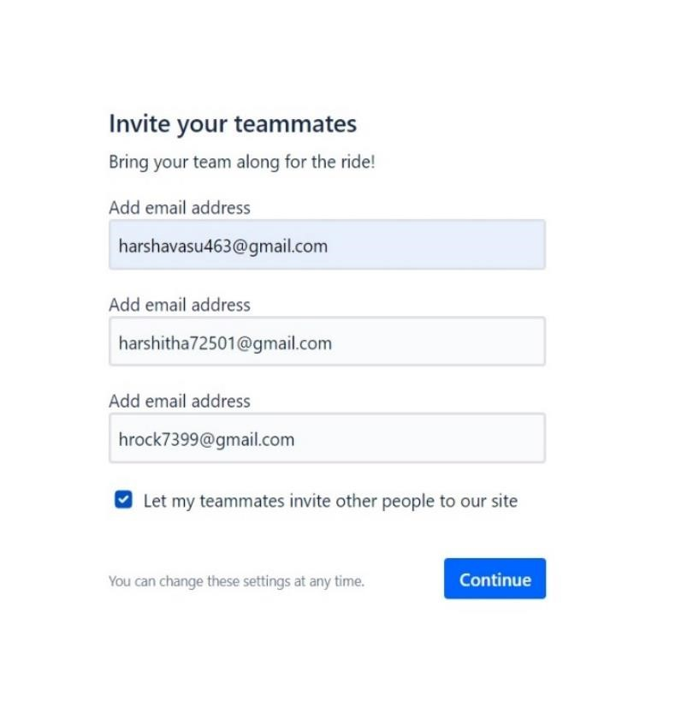

**Step 6 :** On the project dashboard, click on create button at the top in the menu bar to create an Epic.

**Step 7 :** Select the type of the issue i.e. Epic.

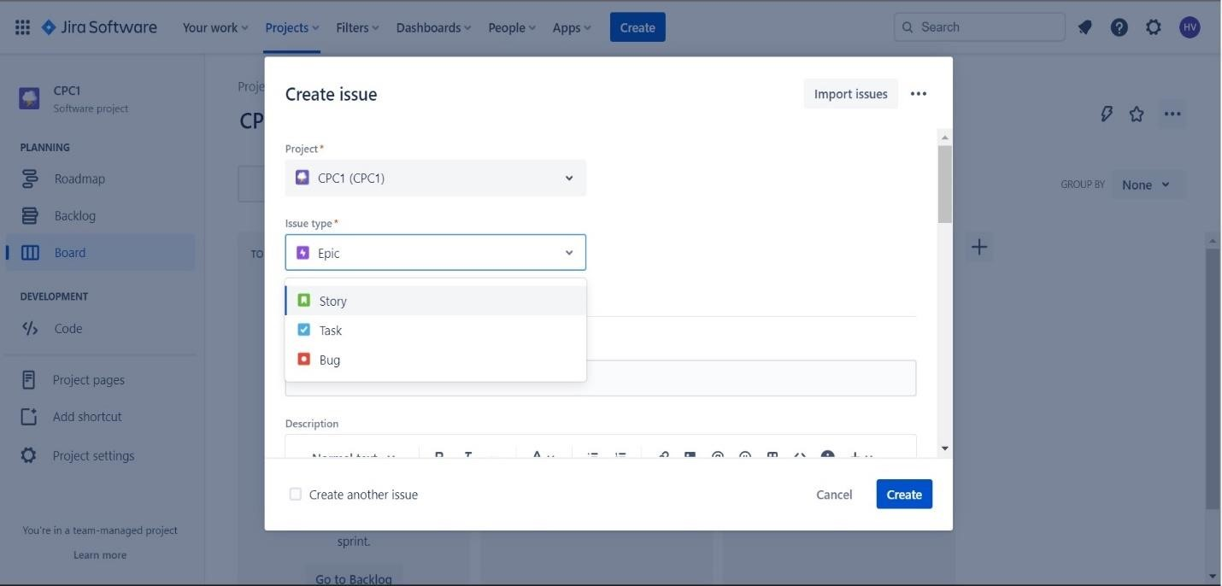

**Step 8 :** In the summary section, Enter the role of the team member.

**Step 9** : In the description section. Add the user stories.

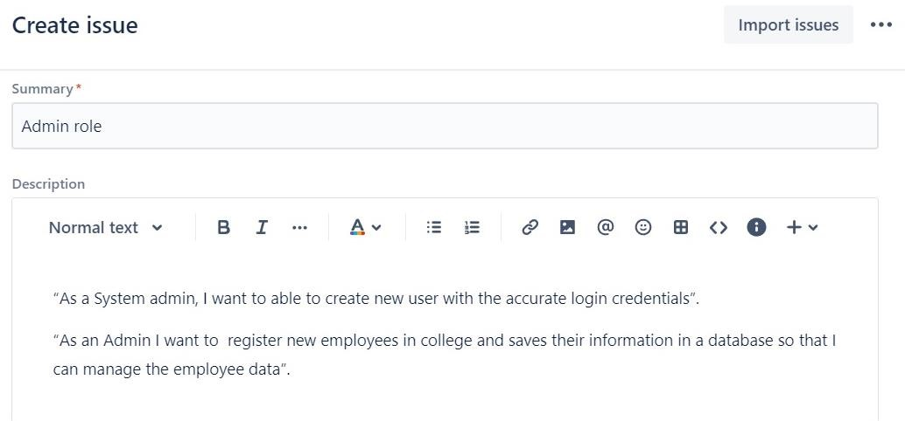

**Step 10 :** Next assign the job role to the team member and click on create.

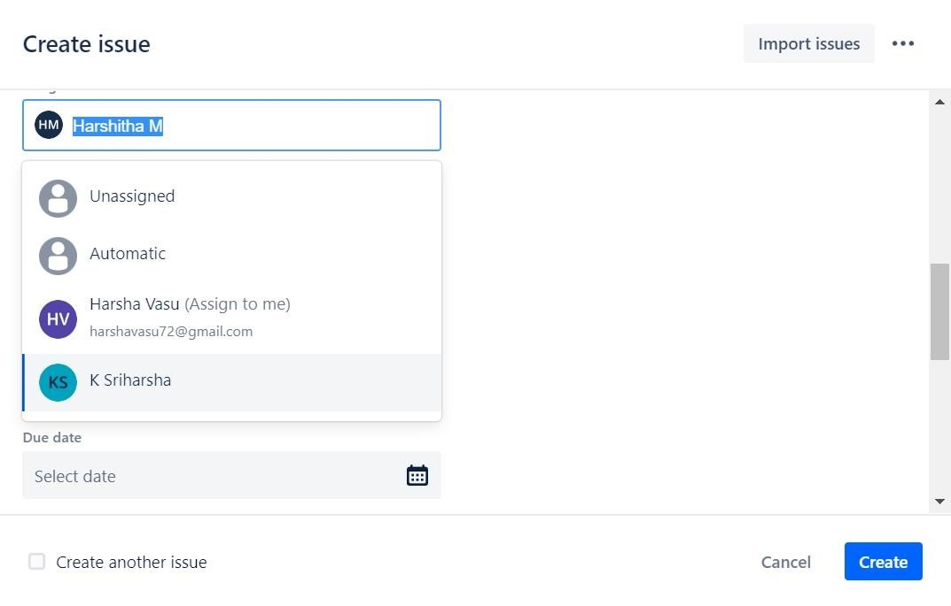

**Step 11 :** The Epic will be assigned to the particular teammate.

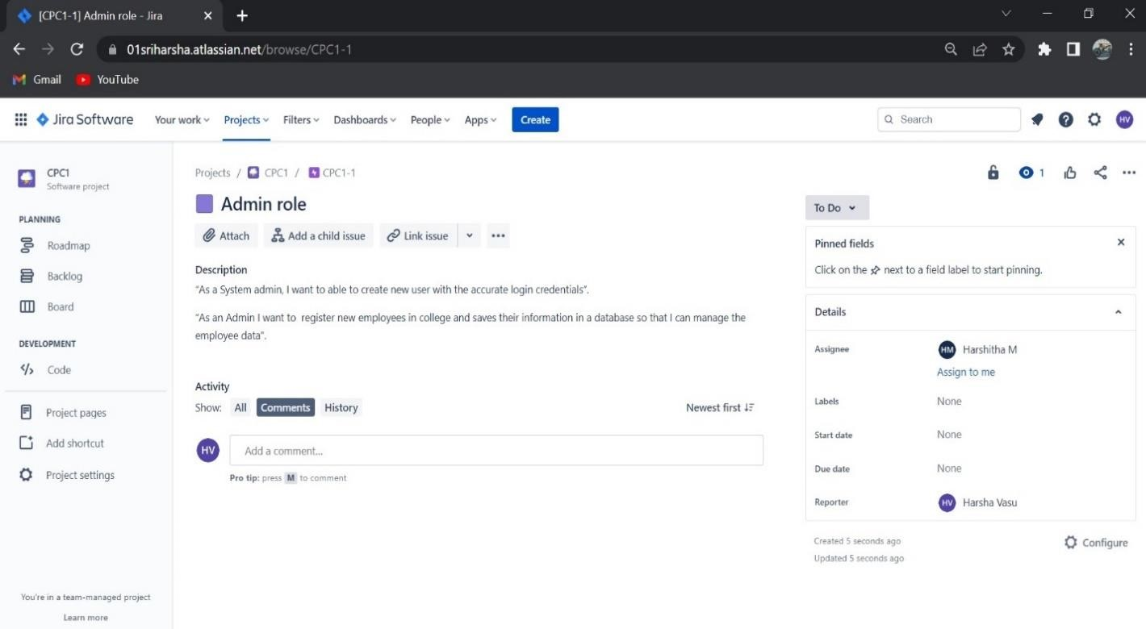

# Experiment – 09

1. **Prepare a test case for user stories using Jira.**

**9.1 Steps to create test case for user stories**

**Step 1 :** On the home page of Jira, Click on apps in menu bar and select explore more apps.

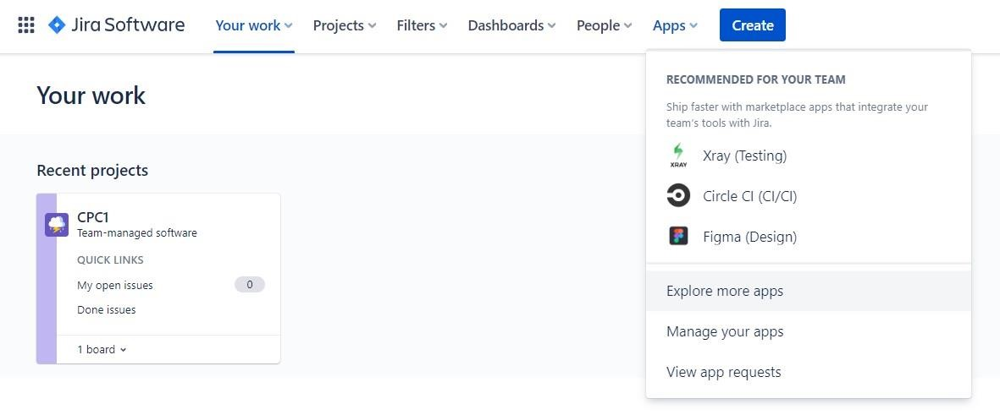

**Step 2 :** Search for zephyr in the search bar and Select the zephyr Scale -Test management for Jira and add it for Jira.

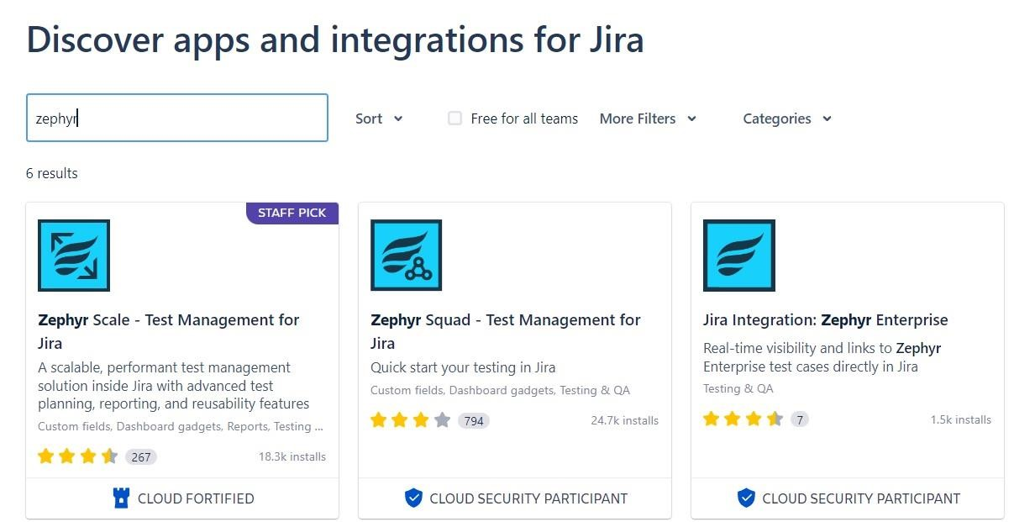

**Step 3 :** After adding Zephyr you can see it on the left side menu of Jira dashboard, Click on it.

**Step 4 :** By default the permissions will be disabled for Zephyr scale. Click **on project settings page** to enable the permissions.

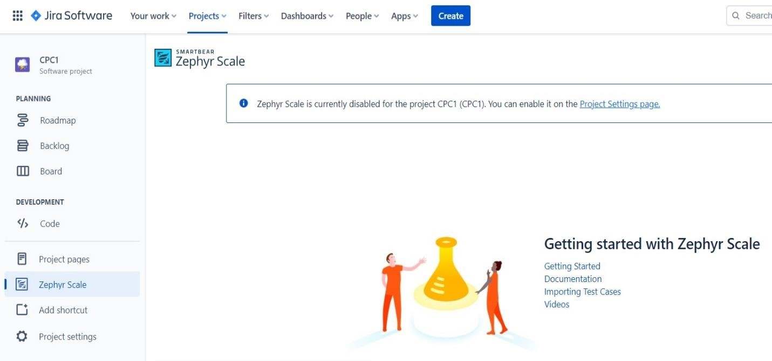

**Step 5 :** Turn the permissions On for everything.

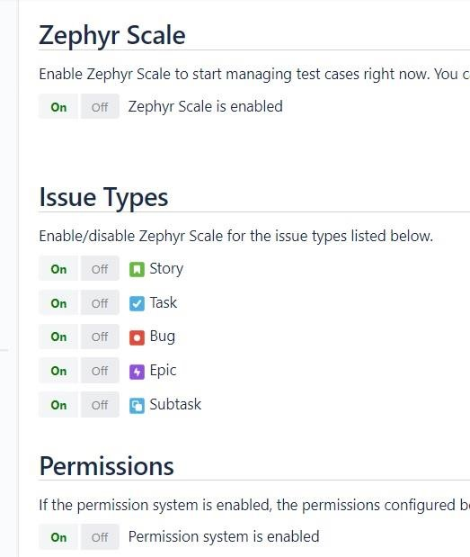

**Step 6 :** Once the permissions are enabled, Enter the test case details and save the details.

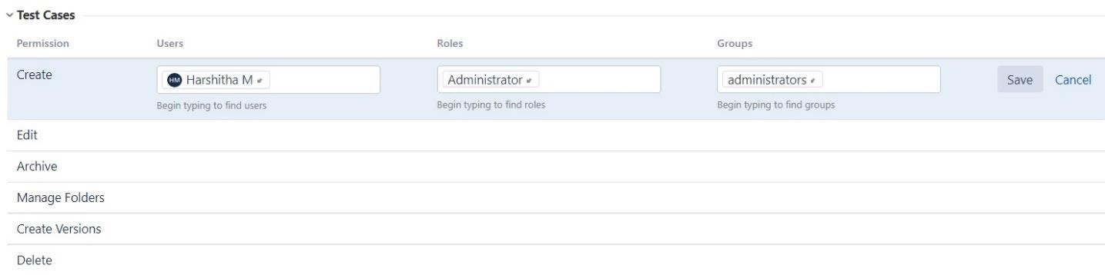

**Step 8 :** Now go back to the Jira dashboard and click on Zephyr scale.

**Step 9 :** The zephyr dash will be appeared.Click on create test case

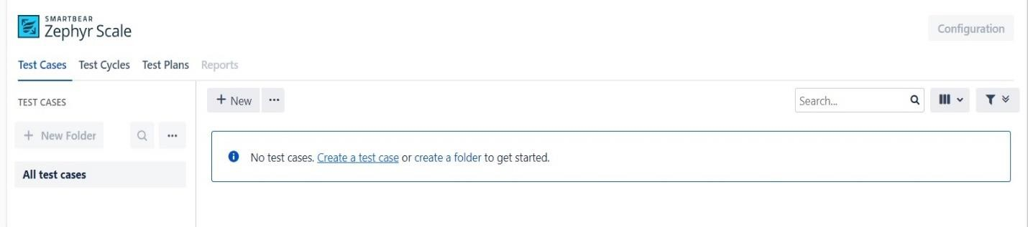

# Experiment – 10

**10. Install and Configure Jenkins.**

## 10.1 Steps to install Jenkins

**Step 1: Setup wizard**

On opening the Windows Installer, an Installation Setup Wizard appears, Click Next on the Setup Wizard to start your installation.

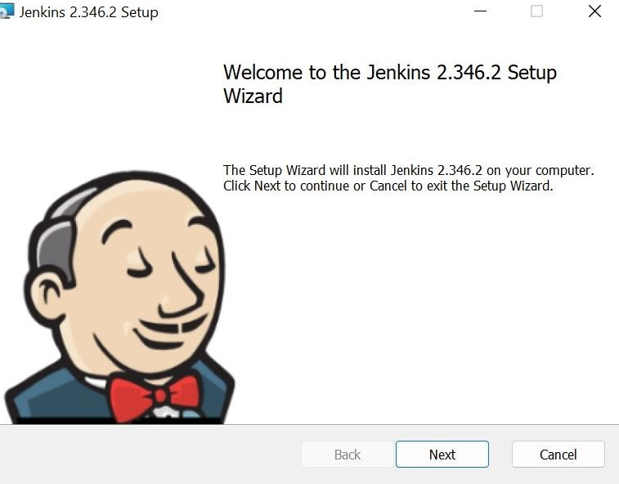

**Step 2: Select destination folder**

Select the destination folder to store your Jenkins Installation and click Next to continue.

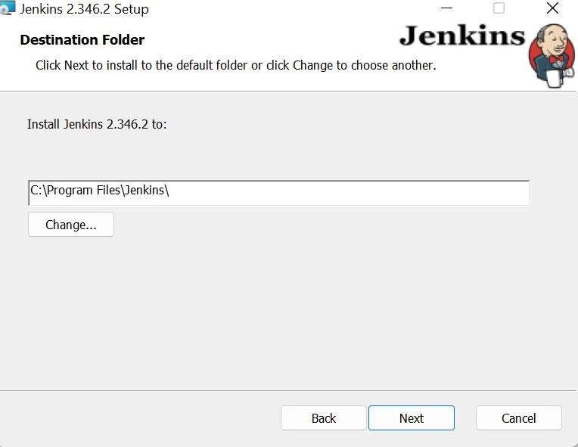

**Step 3: Service logon credentials**

Click On Run service as LocalSystem

On Run service as LocalSystem

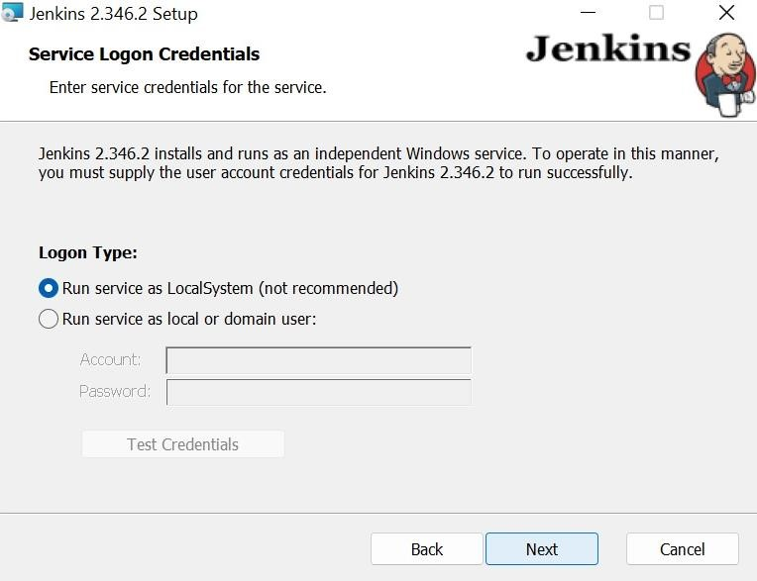

**Step 4: Port selection**

Specify the port on which Jenkins will be running, Test Port button to validate whether the specified port if free on your machine or not. Consequently, if the port is free, it will show a green tick mark as shown below, then click on Next.

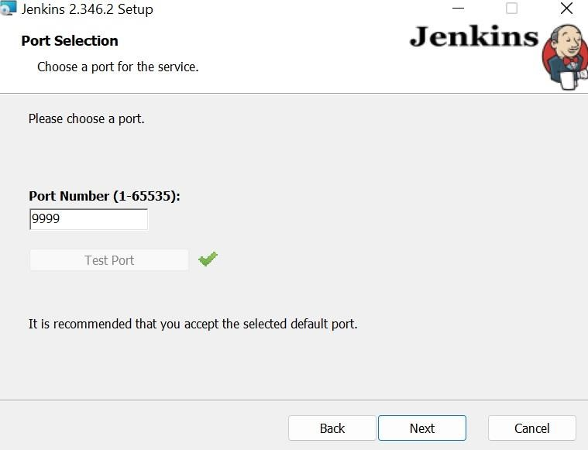

**Step 5: Select Java home directory** The installation process checks for Java on your machine and prefills the dialog with the Java home directory.

* Java home directory.
* If the needed Java version is not installed on your machine, you will be prompted to install it. Once your Java home directory has been selected, click on Next to continue.

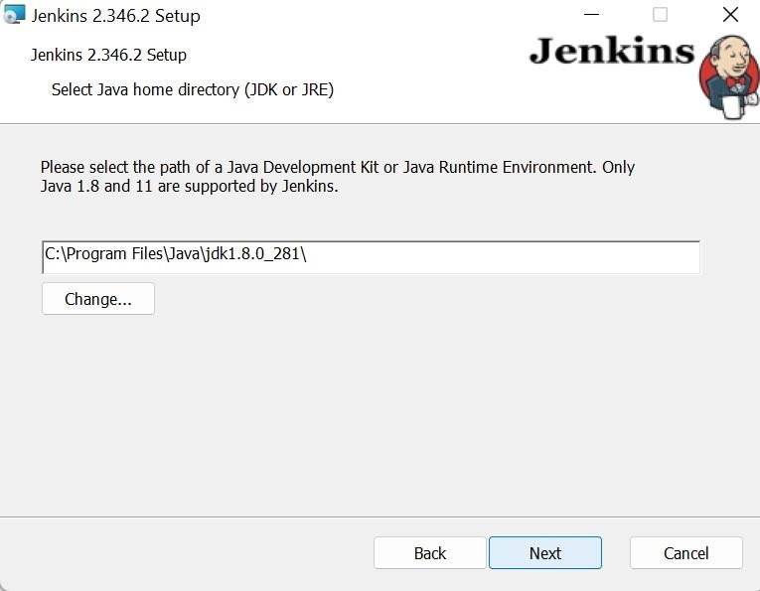

**Step 6: Custom setup**

Select other services that need to be installed with Jenkins and click on Next.

**Step 7: Install Jenkins**

Click on the Install button to start the installation of Jenkins

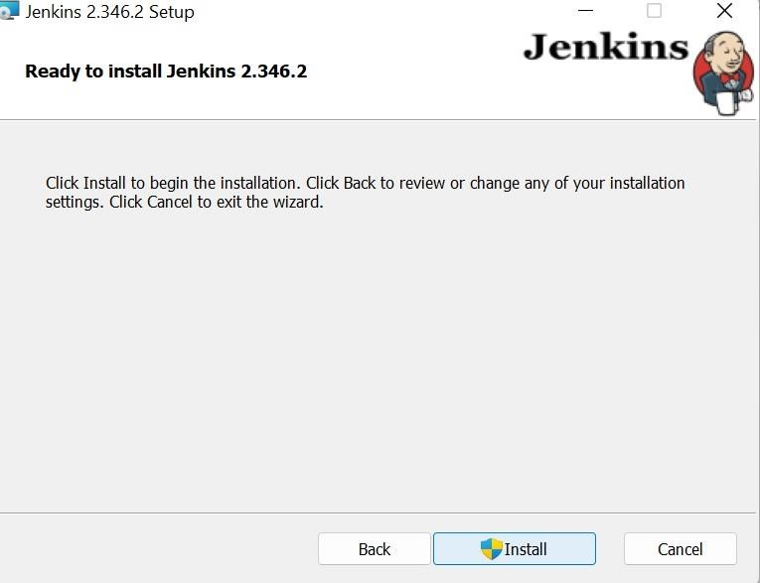

**Step 8: Finish Jenkins installation**

Once the installation completes, click on Finish to complete the installation.

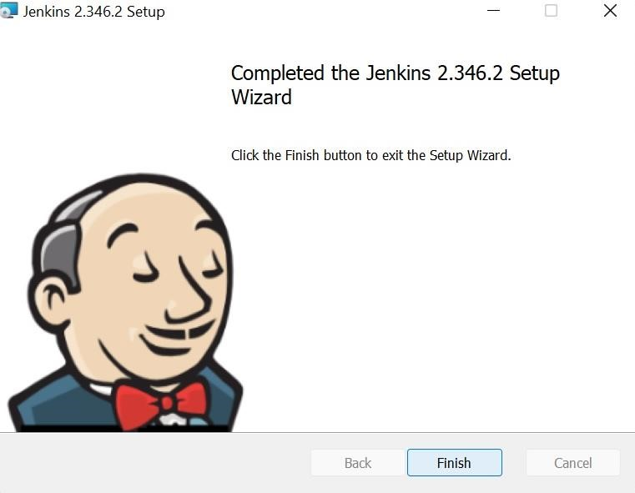

## 10.2 Post Installation Setup or Configuration of Jenkins

**Step 1 :** Browse to http://localhost:9999 (or whichever port you configured for Jenkins when installing it) and wait until the Unlock Jenkins page appears.

**Step 2 :** The page asks for administrator password which can be found in ; C drive →ProgramData →Jenkins → .jenkins → secrets → InitialadminPassword **Step 3 : Copy the password from notepad and paste it.**

**Step 4 : Required files would be downloaded automatically.**

**Step 5 : Set up your username and password to login into Jenkins.**

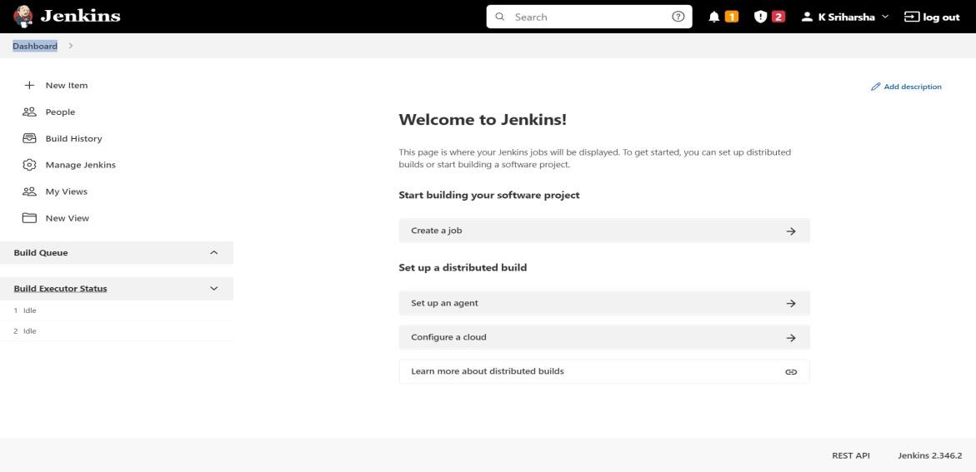

# Experiment – 11

**11. Create a hello world project in Jenkins.**

**Step 1 : Login to Jenkins**

To create a Jenkins freestyle job, log on to your Jenkins dashboard by visiting your Jenkins installation path. Usually, it will be hosted on localhost at http://localhost:8080 If you have installed Jenkins in another path, use the appropriate URL to access your dashboard as shown in the below Jenkins job creation example.

**Step 2 : Create New Item**

Click on “New Item” at the top left-hand side of your dashboard.

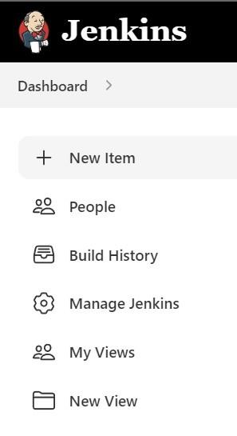

**Step 3 : Enter Item details In the next screen**

1. Enter the name of the item you want to create. We shall use the “Hello world” for this demo.
2. Select Freestyle project

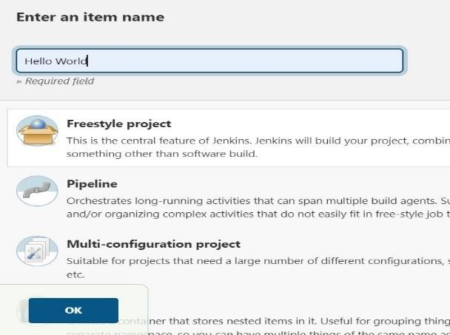

**Step 4 : Enter Project details**

Enter the details of the project you want to test.

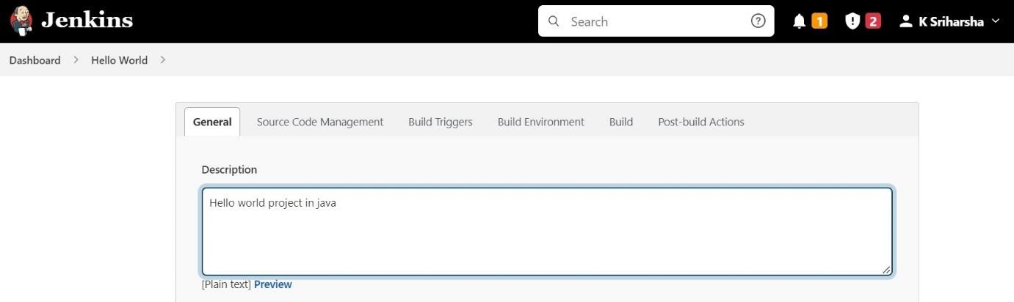

**Step 5 : Enter repository URL**

Under Source Code Management, Enter your repository URL. We have a test repository located at <https://github.com/kriru/firstJava.git>

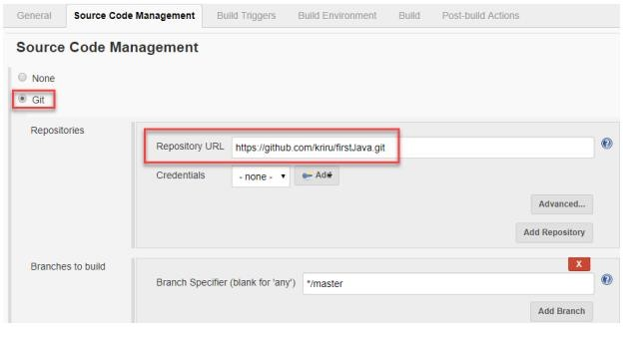

It is also possible for you to use a local repository.

If your GitHub repository is private, Jenkins will first validate your login credentials with GitHub and only then pull the source code from your GitHub repository.

Step 6 : Tweak the settings

Now that you have provided all the details, it’s time to build the code.

Tweak the settings under the build section to build the code at the time you want. You can even schedule the build to happen periodically, at set times.

Under build,

1. Click on “Add build step”
2. Click on “Execute Windows batch command” and add the commands you want to execute during the build process.

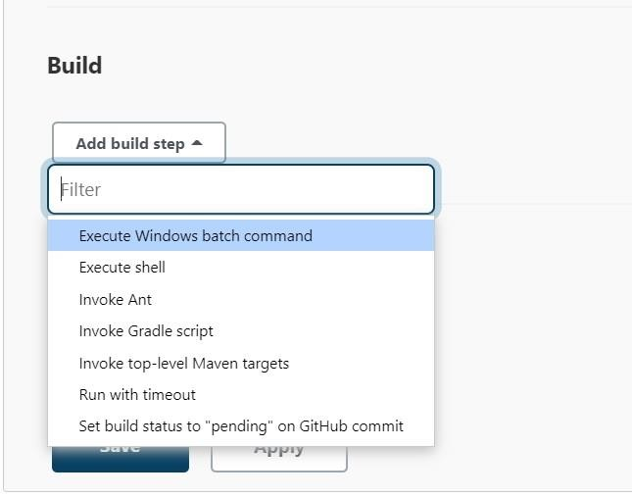

Here, I have added the java commands to compile the java code.

I have added the following windows commands: javac HelloWorld.java java HelloWorld

**Step 7 : Save the project**

When you have entered all the data,

1. Click Apply
2. Save the project.

**Step 8 : Check the status**

After clicking on Build now, you can see the status of the build you run under Build History.

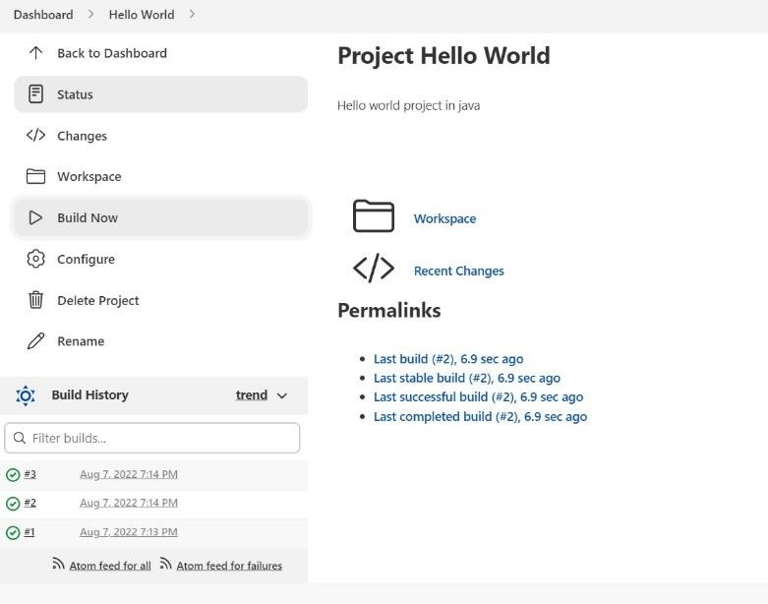

**Step 9: See the console output**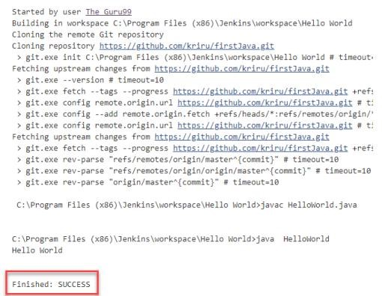

Click on the build number and then Click on console output to see the status of the build you run. It should show you a success message, provided you have followed the setup properly as shown in the below Jenkins create new job example.

# Experiment – 12

**12. Create Git account and configure the repository.**

## 12.1 Steps To create GitHub Account

**Step 1 :** Open [https://github.com](https://github.com/) in a web browser, and then select **Sign up**.

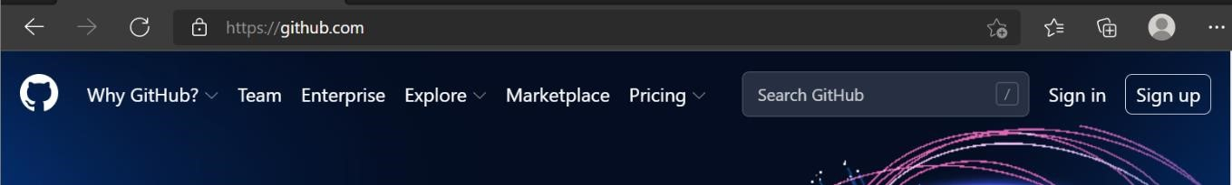

**Step 2 :** **Enter your email** address.

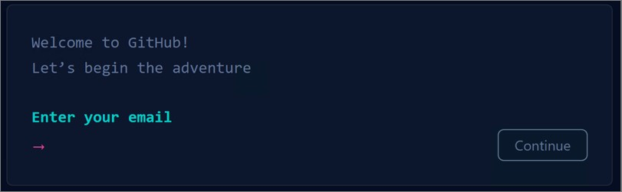

**Step 3 :** **Create a password** for your new GitHub account, and **Enter a username**, too. Next, choose whether you want to receive updates and announcements via email, and then select **Continue**.

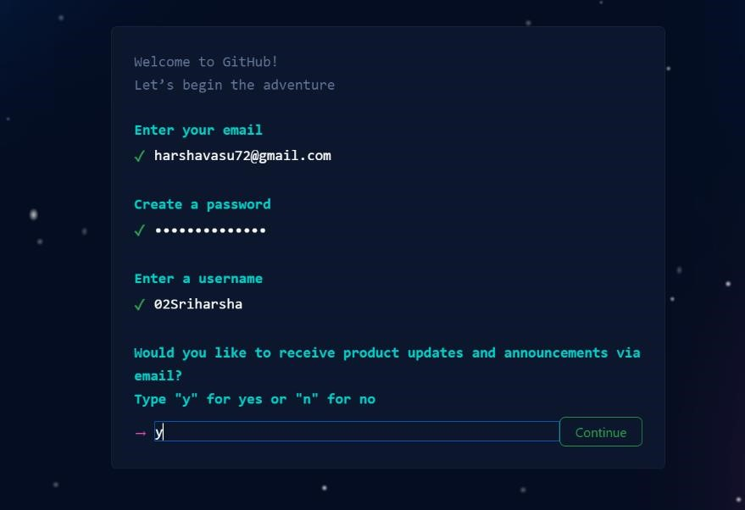

**Step 4 :** **Verify your account** by solving a puzzle. Select the **Start Puzzle** button to do so, and then follow the prompts.

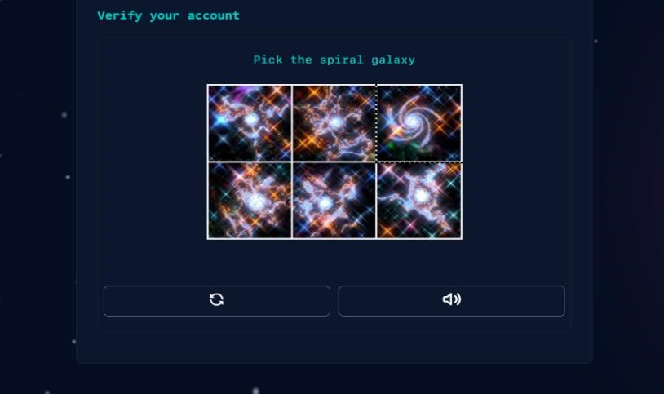

**Step 5 :** After you verify your account, select the **Create account** button.

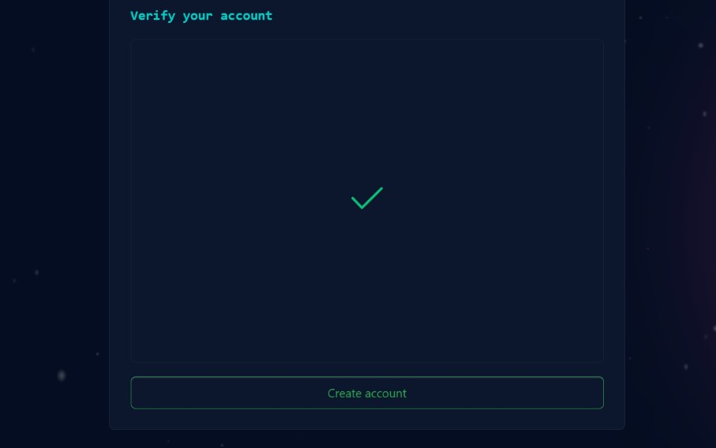

**Step 6 :** Next, GitHub sends a launch code to your email address. Type that launch code in the Enter code dialog, and then press Enter.

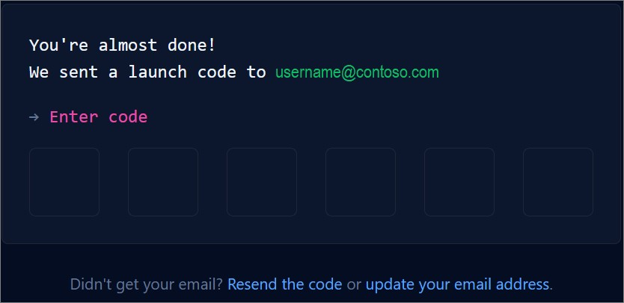

**Step 7 :** GitHub asks you some questions to help tailor your experience. Choose the answers that apply to you in the following dialogs:

* How many team members will be working with you?
* What specific features are you interested in using?

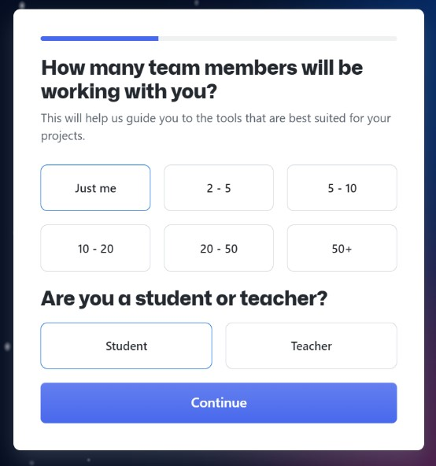

**Step 8 :** On the **Where teams collaborate and ship** screen, you can choose whether you want to use the Free account or the Team account. To choose the **Free** account, select the **Skip personalization** button.

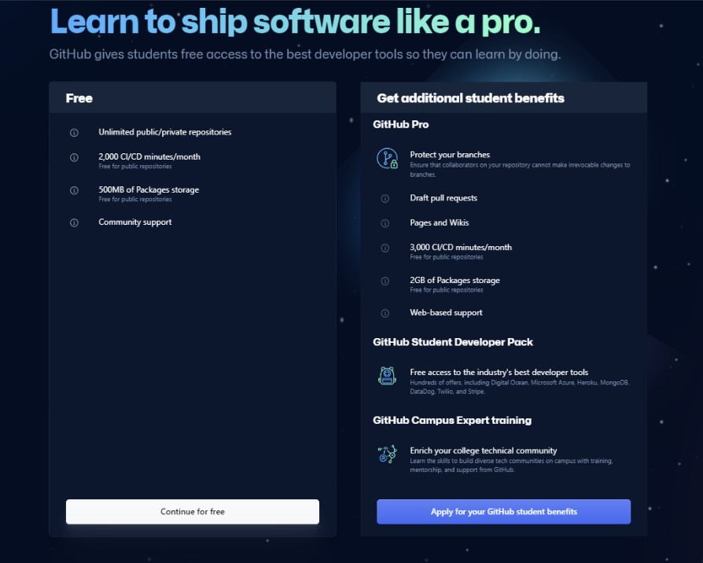

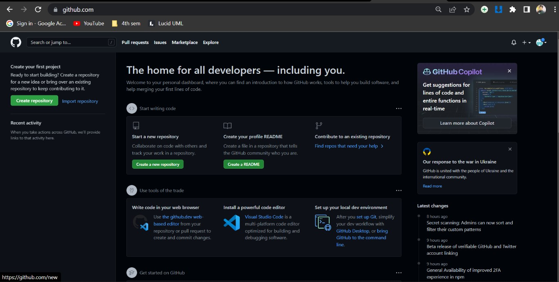

Congratulations! You've successfully created your GitHub account

## 11.2 Steps To Configure GitHub Repository

**Step 1 :** Log into the GitHub administrative console

**Step 2 :** Move to the GitHub Repositories page

**Step 3 :** Click on the green “New Repository” button



**Step 4 :** Enter the name of the [GitHub repository](https://www.theserverside.com/blog/Coffee-Talk-Java-News-Stories-and-Opinions/Master-the-GitHub-repository-tutorial)

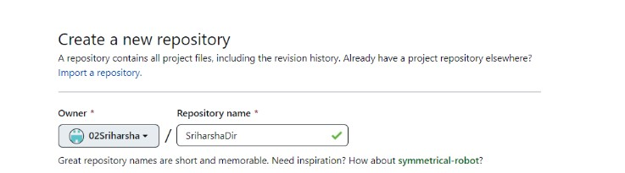

**Step 5 :** Include a description (optional)

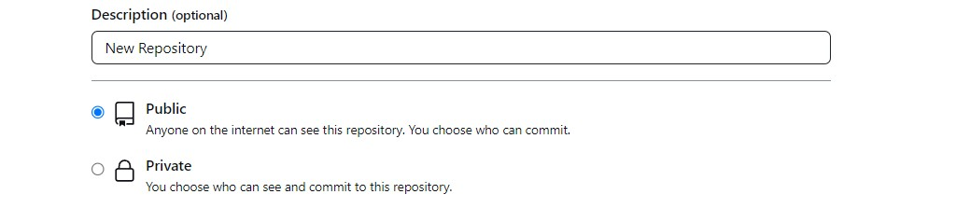

**Step 6 :** Choose to make this a public or [private GitHub repository.](https://www.theserverside.com/feature/Want-a-private-GitHub-repository-It-comes-with-a-catch)

**Step 7 :** Add a README (optional)

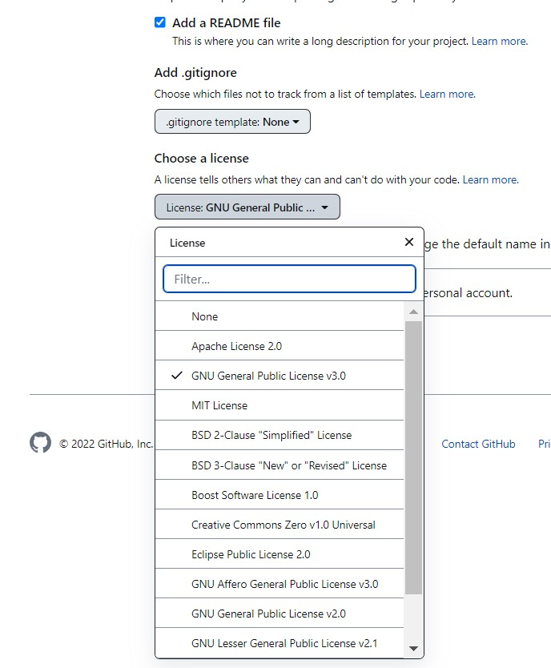

**Step 8 :** Include a .git ignore file for your development framework (optional)

**Step 9 :** Choose a fair use license

**Step 10 :** Click the green “Create Repository” button to finish the process

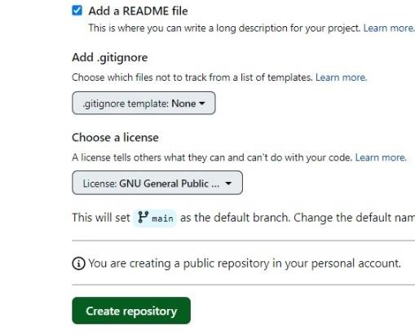



# Experiment – 13

**13. Create Sitemap using Figma Tool.**

## 13.1 Steps to download and login into Figma Application

**Step 1 :** Go to your preferred browser and search figma download for windows. Click on the official figma website link.

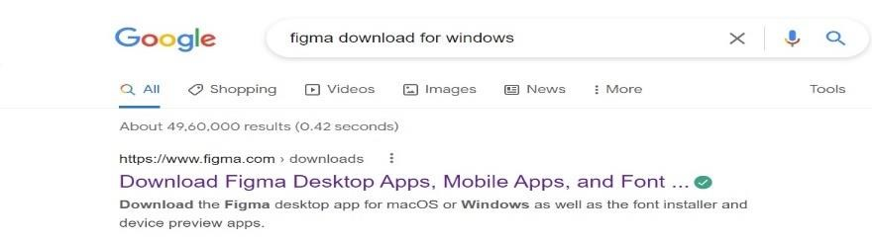

**Step 2 :** At the bottom of the page, Select the Desktop app for windows. An .exe file would be begin to download.

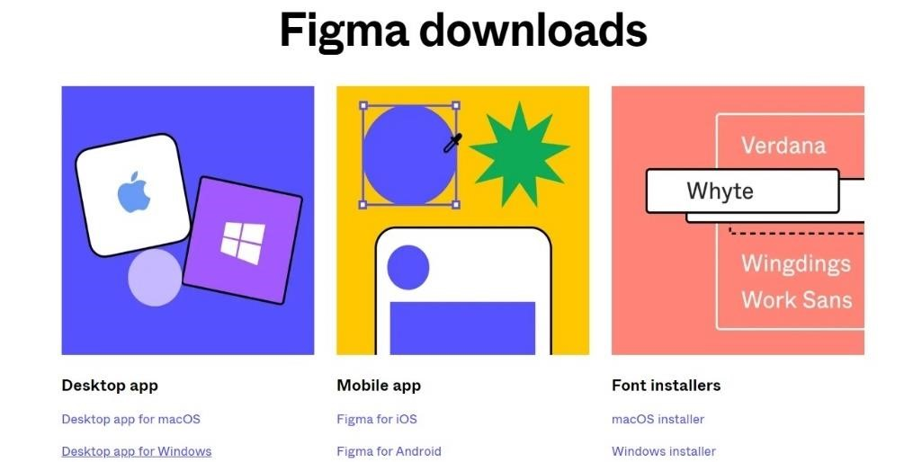

**Step 3 :** Run the downloaded app. It will ask for login into Figma account click on login.

**Step 4:** The link will be redirected into the figma website. Click on create one.

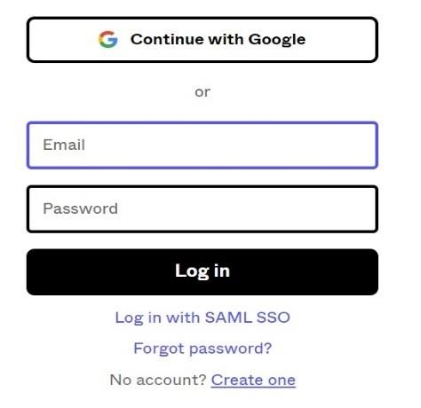

**Step 5 :** Click on continue with google and enter the Gmail credentials.

**Step 6 :** In the next page, It will ask about yourself fill the tabs and click on create account.

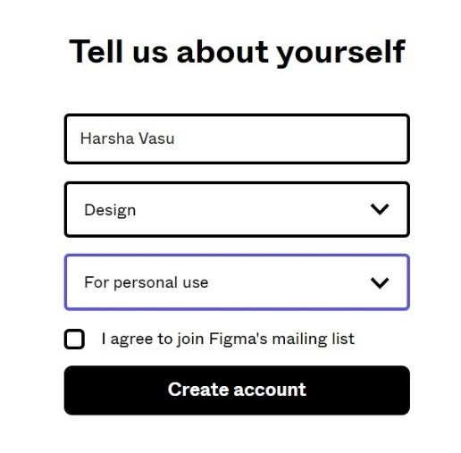

**Step 7 :** The page will be automatically redirected back to figma application.

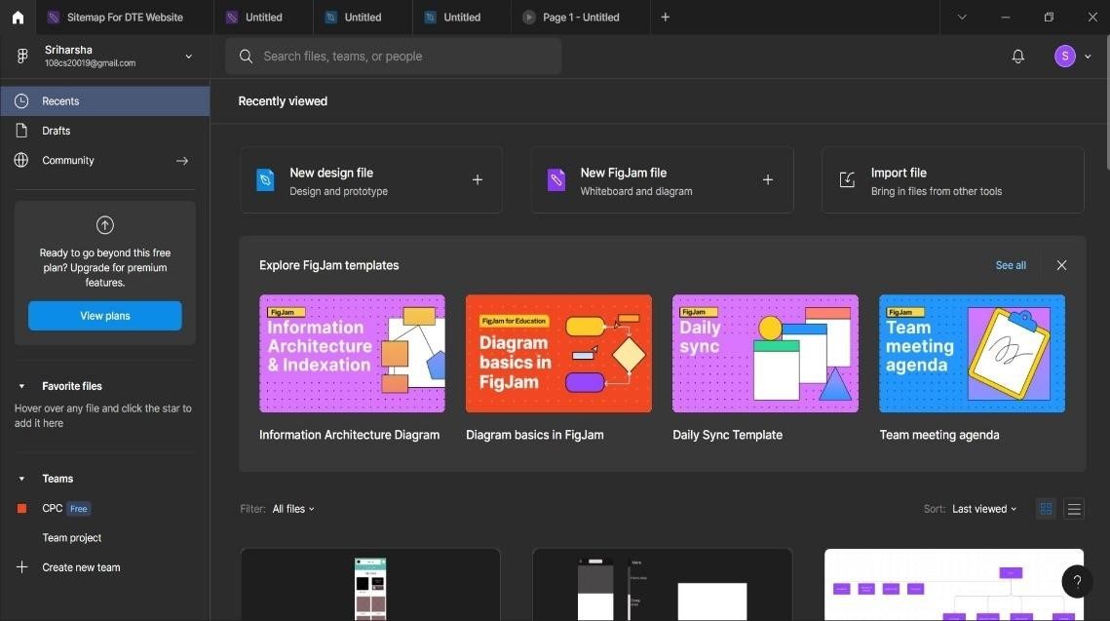

## 13.2 Steps to create Sitemap in Figma

**Step 1 :** Click on NewFigjamFile in the menu of the home screen or click on new tab option at the top and select FigjamFile.

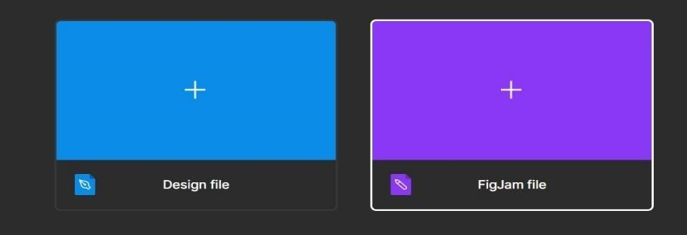



**Step 2 :** A black workspace will be appear with different types of tools.

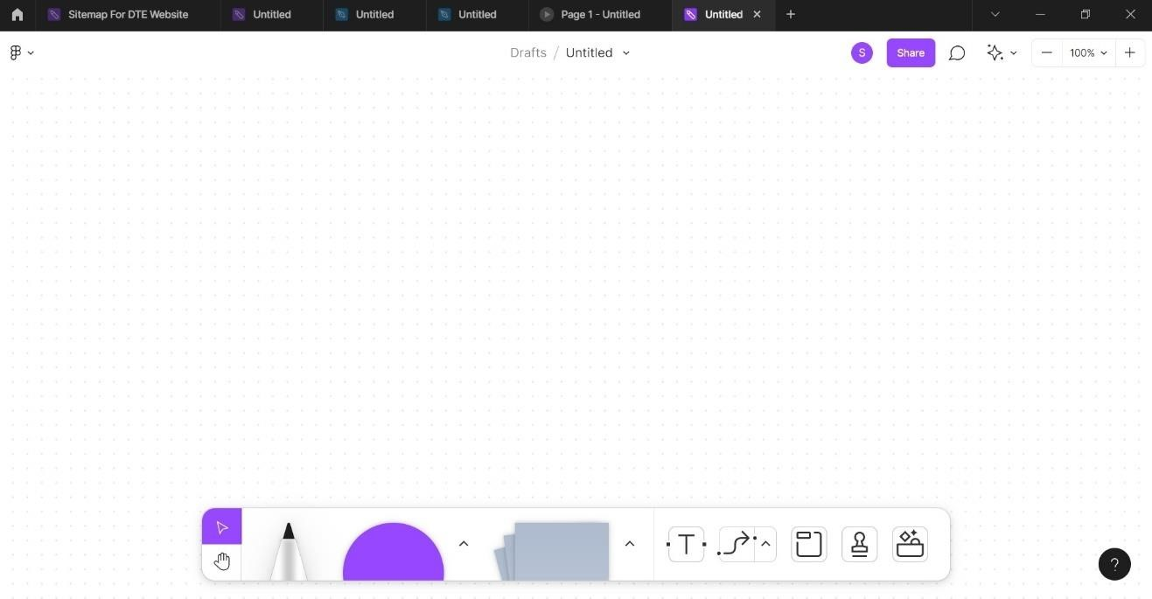

**Step 3 :** Use the different tools that are available to create a sitemap of an website.

**Step 4 :** Using Clipboard, click on ellipse and choose it as square

**Step 5 :** Make some clips by pulling blocks from ellipse

**Step 6 :** Arrange the blocks as shown in the below diagram.

# Experiment – 14

**14. Create Wireframe using Figma Tool.**

## 14.1 Steps to create wireframe in Figma

**Step 1 :** Download the Figma Application Through Any browser

**Step 2 :** Now install the application in the desktop

**Step 3 :** Open the application and create an account using Google account

**Step 4 :** Click on DesignFile in the menu of the home screen or click on new tab option at the top and select DesignFile.

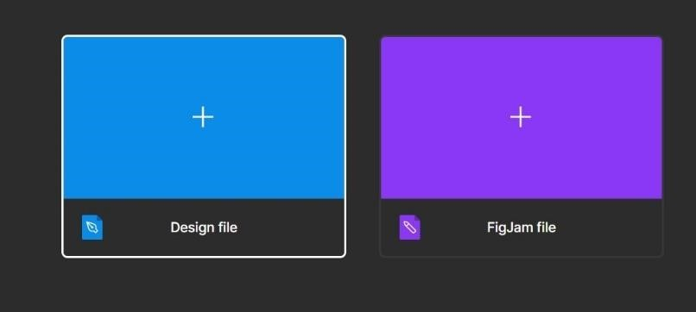

**Step 5 :** A black workspace will be appear with different types of tools.

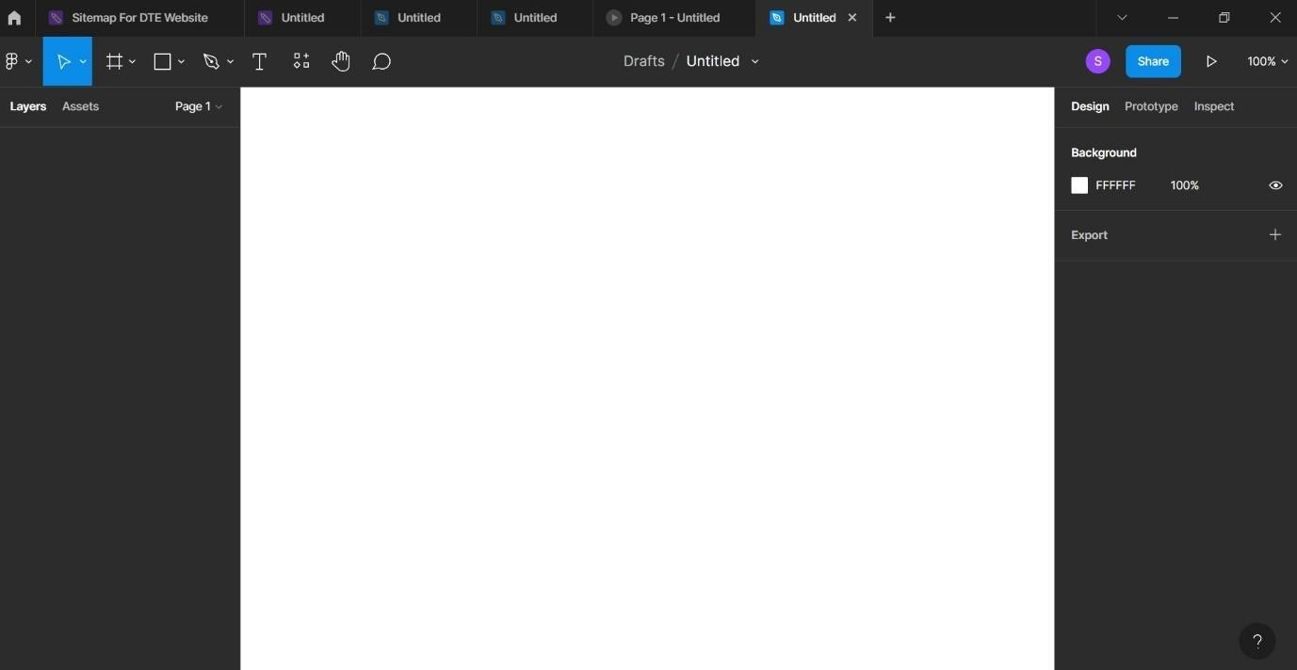

**Step 3 :** Use the different tools that are available to create a Wireframe of an UI of a website or an application.

**Step 4 :** Start of by clicking on frame tool on toolbar and select t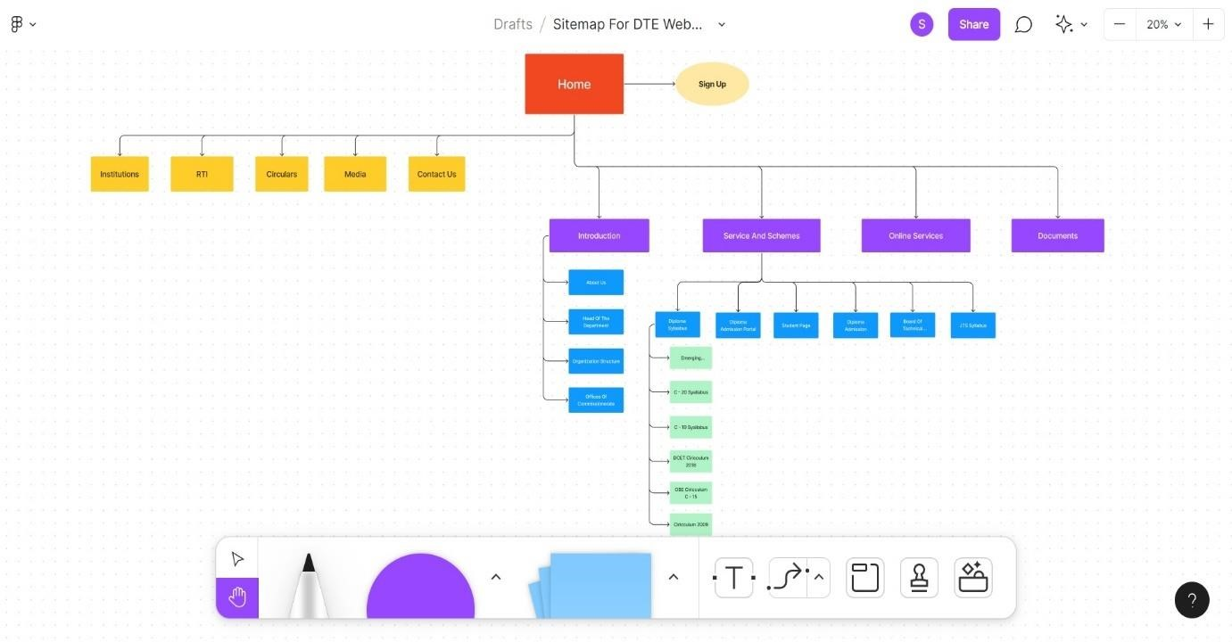

**Step 8 :** Select the scrolling list and select the particular scrolling according to your choice and click on show prototype settings.

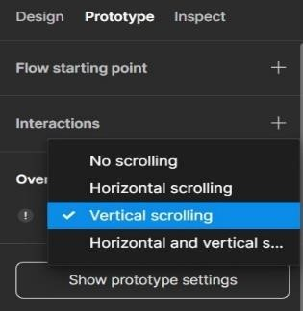

**Step 9 :** Select your device. Change background of the device(optional) and select whether portrait or landscape then click on play button at the top.

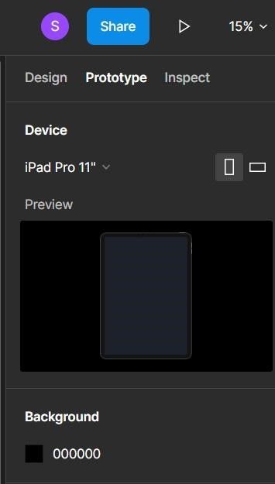

**Step 10 :** The actual design will appear on the device you can monitor how design will reflect on the actual device and can be scrolled too as shown below.

